Press Release
Reiskirchen, 10.11.2021

Contact details
yes or no Media GmbH
Claudia Wörner
Vor dem Lauch 4
D-70567 Stuttgart
Phone +49 711 75 85 89 00
claudia.woerner@yes-or-no.de
www.yesorno.de

Bianca Dort
Marketing Manager
Tel +49 6408 84-6842
bianca.dort@weiss-technik.com

Weiss Technik GmbH
Greizer Straße 41-49
35447 Reiskirchen
Deutschland
www.weiss-technik.com

Premiere at Weiss Technik
Solar simulation for the hydrogen age

Weiss Technik, market leader for environmental simulations, has created the world's first sunlight simulation test stand for vehicles with fuel cells. The central innovations are explosion protection according to the ATEX standard and a lighting system that reduces test preparation time to a minimum.

For function and ageing tests, vehicles are also exposed to intensive irradiation with light. Tests of fuel cell vehicles require special safety precautions, as they are powered by the volatile and explosive gas hydrogen. Weiss Technik was the first supplier worldwide to develop a specialised test chamber for fuel cell vehicles.

Their ATEX safety concept continuously analyses the air in the test chamber and detects even the smallest traces of the explosive gas. In the event of an error message, the safety PLC switches the system off immediately. To prevent electrostatic charging and sparking, the vehicles are earthed in the test chamber.

A technical innovation from Weiss Technik is the puncture-proof double filter disc system between the test chamber and the lighting units. The sunlight emitters are permanently installed in the ceiling of the test chamber. In order to precisely control the radiation intensity, sensors adjust the desired intensity directly on the vehicle. This adjustment process takes only a few seconds. Since this technology removes the need for mechanics to adjust the height of sunlight emitters, Weiss Technik's new product is 30 percent more cost-effective than conventional sunlight simulations.

1,594 characters (including spaces)

Reprint free of charge. Please state Weiss Technik GmbH as a source.
Picture material:
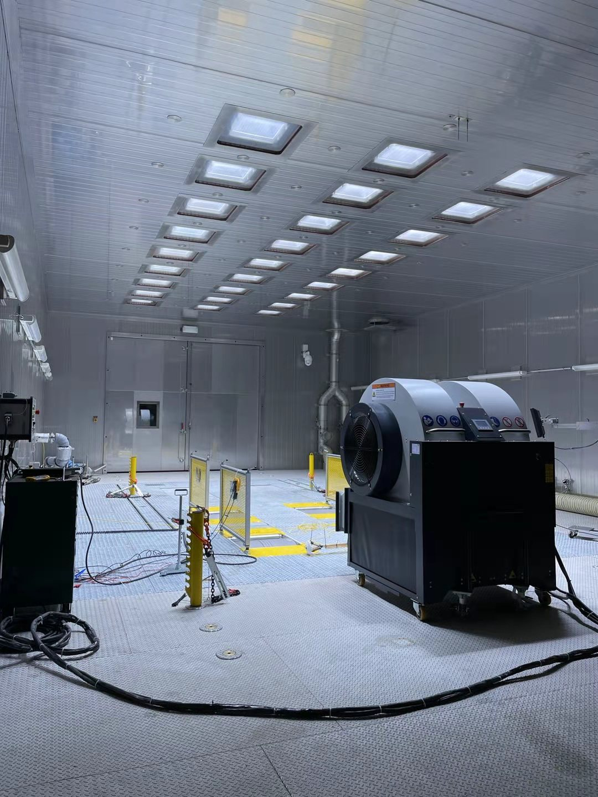
Picture: Weiss Technik GmbH, own image
The emitters of the sunlight simulation by Weiss Technik are permanently installed in the ceiling of the test chamber.

The Weiss Technik companies
Weiss Technik companies include the product areas of environmental simulation, thermal technology, air conditioning technology and pharmaceutical technology (www.weiss-technik.com). Customers receive solutions and products that are used in research and development as well as in manufacturing and quality assurance. A strong sales and service organisation with 22 companies in 15 countries at 40 locations supports customers and ensures the operation of the systems - around the globe. The Weiss Technik companies are part of the Schunk Group, which is based in Heuchelheim near Gießen/Germany.
Schunk Group
The Schunk Group is a global technology group. The company is a leading provider of products made from high-tech materials – such as carbon, technical ceramics and sintered metal – as well as machines and plants – from environmental simulation to air-conditioning technology and ultrasonic welding to optical machines. The Schunk Group has over 9,100 employees across 29 countries and generated a turnover of 1.35 billion euros in 2019.

