Press release
Reiskirchen, 03.01.2022

Editor
yes or no Media GmbH
Claudia Wörner
Vor dem Lauch 4
D - 70567 Stuttgart
Tel +49 711 75 85 89 00
claudia.woerner@yes-or-no.de
www.yesorno.de

Contact details
Bianca Dort
Marketing Manager
Tel +49 6408 84-6842
bianca.dort@weiss-technik.com

Weiss Technik GmbH
Greizer Straße 41-49
35447 Reiskirchen
Deutschland
www.weiss-technik.com

Mobile Plug&Test Lab for electrical energy storage systems
weisstechnik and DSA have combined their expertise for an innovative test system

The market for electric vehicles is on the move and the pressure to introduce new innovations in the field of electric mobility is increasing. This also increases the need for readily available test solutions for the standard temperature and climatic testing of lithium-ion batteries found in vehicles. weisstechnik and DSA have developed a mobile, container-based plug & test solution for just this purpose. This enables standard-compliant testing and fulfils all the necessary safety specifications.

Mobile and ready for testing in just one day
The test laboratory is mobile and designed as a plug & test system. It is versatile and able to cover a wide range of tests for high-voltage batteries. This makes it suitable for the expansion of existing testing capacities, as a replacement for testing facilities that have failed at short notice and for the cost-effective establishment of new testing locations, for example for start-up companies. At the same time, it offers highly convenient tests and safety equipment according to Hazard Level 6. As a turnkey solution, it relieves the burden on in-house staff, who no longer have to deal with the planning and commissioning of a test solution. Since the container is a mobile structure, a simplified official approval can be expected during installation.

Large testing range in a small area
The fully air-conditioned Plug&Test Lab achieves temperatures from -40 to +80. °C with a temperature change rate of 3 K/min. and humidities of 10 to 95 % RH. It is as suitable for carrying out short end-of-line tests and prototype tests as it is for long-term testing. The testing software with its stored standard test scenarios is particularly user-friendly. After a short training period, users can program their own test scenarios. All the interfaces of the testing system, software and visualisation are already perfectly coordinated with each other.

Tests and standards
The test editor and the test tools of the compact test system are designed to perform a wide variety of electrical and physical tests on the batteries, the battery management system and individual components. These include, for example, tests for charging and discharging cycles, the simulation of different climatic conditions or entire seasons, driver and load profiles as well as insulation and leak tests. All data can be easily read out and fed directly into a database or made available for further processing and analysis.

Compact on the outside, lots of space on the inside
Despite the compact external dimensions of a 40" container, the system contains a complete test laboratory including test chamber, battery charging/discharging unit, measurement technology, test stand automation, cooling water treatment and operating station. It is delivered by semitrailer and can be easily moved later if required. All that is required for installation is a concreted surface or a strip foundation and the necessary connections. The test room measures (HxWxD) 2.3 x 2.2 x 3 m and is suitable for testing battery packs and smaller electric vehicles. All connections are designed in such a way that they can be connected quickly and easily, so that startup can be achieved within one day.

Cleverly combined expertise
The Plug&Test Lab combines the testing and industry expertise of two highly specialised companies. weisstechnik is a long-standing and world-leading specialist in environmental simulation. One focus is the automotive sector, which the company supplies with a wide range of test solutions from compact climatic chambers to chassis dynamometers for complete vehicles. As a leading expert in innovative and customised diagnostic solutions for automotive electronics, DSA offers hardware, software and services for testing vehicles and components such as high-voltage batteries. weisstechnik is responsible for the entire construction of the container, air-conditioning technology and project coordination. DSA supplies the hardware and software for the lab automation, measurement technology and test GUI for the battery tests, the DUT contacting and the higher-level safety PLC.

(4,253 characters with spaces)
Reprint free of charge. Please state Weiss Technik GmbH as a source.

Photo material:
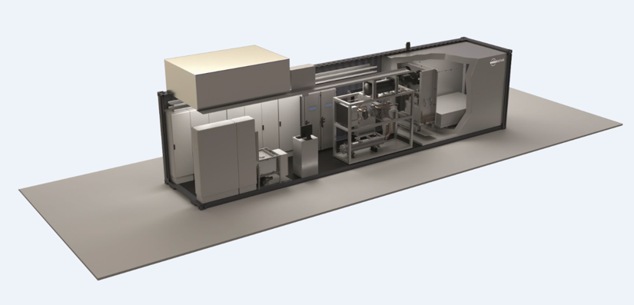
Picture 1: The Plug&Test Lab integrates test chamber, test technology and operating station in one container.

The Weiss Technik companies
The Weiss Technik companies include the product areas of environmental simulation, heating technology, air conditioning technology and pharmaceutical technology (www.weiss-technik.com). Customers receive solutions and products that are used in research and development as well as in production and quality assurance. A strong sales and service organisation with 22 companies in 15 countries at 40 locations supports the customers and ensures the operation of the systems - around the globe. The Weiss Technik companies are part of the Schunk Group based in Heuchelheim near Gießen.
Schunk Group
The Schunk Group is a global technology company. The company is a leading supplier of products made of high-tech materials – such as carbon, technical ceramics and sintered metal – as well as machines and systems – from environmental simulation and air conditioning to ultrasonic welding and optical machines. The Schunk Group has around 9,000 employees in 29 countries and achieved sales of €1.2 billion in 2020.

