Press Release
12 November 2019

Contact
Marco Michels
Press Officer
Tel.: +49 641 5817427
marco.michels.external@weiss-technik.com

Gerlinde Schowalter
Brand Identity and PR Manager
Tel.: +49 6408 846231
gerlinde.schowalter@weiss-technik.com

Weiss Umwelttechnik GmbH
Greizer Strasse 41–49
35447 Reiskirchen
Germany
www.weiss-technik.com

An end-of-line test tunnel with a transport system
and electrical contacting

Electronic components need to function reliably throughout their entire service life, especially in the case of safety-relevant vehicle components. This is why after production, such products are subjected to a 100% function test at extreme temperatures in end-of-line test tunnels. As an experienced end-to-end provider, weisstechnik plans and constructs these test tunnels in accordance with customer and test specimen requirements.

100% function tests for maximum reliability
weisstechnik end-of-line test tunnels are compact and highly precise conveyor tunnel systems. They are usually comprised of a cold, a heat and a cooling tunnel. The systems are used to test whether electronic components or component assemblies function under extreme temperatures. Many of the sensitive components tested come from the automotive supplier and electronics industries.

Customised and with a modular structure
The end-of-line tunnels, which feature a modular structure and are designed to meet test specimen and testing requirements, carry out both electrical tests and combined electro-pneumatic or electro-hydraulic tests. They are designed for continuous 24/7 industrial operation and are able to reliably test even large quantities within a very short space of time. The tunnel systems can be arranged as a square or in a line. If necessary, the return system for the workpiece carriers can be installed under the tunnel system to save space. Both manual and automated solutions are available for loading and unloading workpiece carriers.

Temperature-controlled tunnels with an integrated contacting station
The temperature-controlled tunnels with a workpiece carrier transport system form the heart of the systems. The test specimens are normally initially cooled down to as low as -40°C and fed into a contacting station to undergo function tests. They are then heated-up to 120°C and undergo a second function test before being taken through the cooling tunnel, after which they can be removed and further processed. The cycle time and the temperature change duration should be planned precisely to ensure that everything functions smoothly.

All interfaces fully under control
For the smooth integration of an end-of-line tunnel, it is essential that all interfaces are carefully planned. This not only applies to connecting the software to an existing PLC but also to integration into the production line and the design of the individual tunnels. The cooling tunnel can be air cooled, cooled via an air circulation system with a water-cooled heat exchanger or operated as an air circulation system with direct cooling provided by a refrigeration unit. The position of the machine unit with the control cabinet and the compressed air dryer should be planned in such a manner that all technical and spatial requirements are met.

Experience, network and service
As an end-to-end provider, weisstechnik has been responsible for the planning, production, commissioning and maintenance of end-of-line test tunnel systems for 30 years. Our expertise in the field of environmental simulation enables us to guarantee our customers low switching rates and an extremely precise test temperature. This temperature has a default value of ± 2 K and can be adjusted to ± 1 K if needed. Using the technology of the systems as a basis, we also develop hardening tunnels and calibration tunnels. When implementing these plans, we rely on the expertise and services of a well-coordinated network of specialists. When it comes to operations, our qualified service technicians ensure that systems are working correctly – with reaction times of six to four hours where required.

For more information, please visit www.weiss-technik.com
(3778 characters incl. spaces)
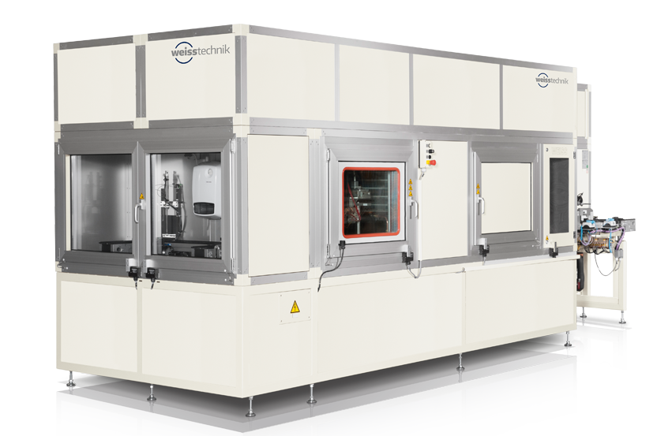

weisstechnik end-of-line test tunnels for 100% function tests are configured in accordance with customer requirements and are suitable for a wide range of different test specimens.

Reprint free of charge. Please specify Weiss Technik Companies as the source.

The Weiss Technik Companies
Under the slogan “Test it. Heat it. Cool it.”, the Weiss Technik Companies offer solutions that are used around the world in research and development as well as in the production and quality assurance of numerous products. A strong distribution and service organisation with 22 companies at 40 locations in 15 countries ensures optimum customer support and guarantees a high degree of operational safety. The brand weisstechnik® includes individual solutions for environmental simulation, clean rooms, climatic engineering, air dehumidification and containment solutions. With its test systems from the field of environmental simulation, different environmental influences around the globe can be simulated in time-lapse mode. The product is tested under real load for its functionality, quality, reliability, material resistance and service life. The dimensions of the test equipment range from laboratory test cabinets to test chambers for aircraft components with a volume of several hundred cubic metres. The Weiss Technik Companies are part of the Schunk Group based in Heuchelheim near Gießen, Germany.

Schunk Group
The Schunk Group is a globally operating technology company with a global business unit structure. The company is a leading supplier of products made of high-tech materials – such as carbon, technical ceramics and sintered metal – and machines and systems – from environmental simulation and air conditioning to ultrasonic welding and optical machines. The Schunk Group has more than 8500 employees in 29 countries and achieved sales of €1.28 billion in 2018.

