Press Release
Contact
Marco Michels
Press commissioned
Tel +49 641 58174-27
marco.michels.external@weiss-technik.com

Claudia Lorch
Market Manager Life Science
Tel +49 6408 84-6760
claudia.lorch@weiss-technik.com

Weiss Klimatechnik GmbH
Greizer Straße 41-49
35447 Reiskirchen
Germany
www.weiss-technik.com

weisstechnik® installs Particle Monitoring and Surgical Smoke Extraction Systems in Operating Theatres of Asklepios Orthopädische Klinik Hohwald .

Reiskirchen, 2 May 2019. The surgical ward of Asklepios Orthopädische Klinik Hohwald has been rebuilt. Of particular importance to the clinic operator Asklepios were sustainability of technology and the creation of safe and ergonomic conditions for patients and medical staff equally. For this reason, the operator opted for the low-turbulence displacement flow clean-air ceilings with continuous particle monitoring and surgical smoke extraction systems made by weisstechnik.

Renowned special clinic in Saxon Switzerland
With 101 beds and its own spine centre, Asklepios Orthopädische Klinik Hohwald is one of the leading orthopaedic and endoprosthetic institutions in Germany. In the planning of two new operating theatres, modern and safe technical equipment was also designed in order to save energy. Marc Eisele, Head of Medical Technology in the Architecture and Construction Division at Asklepios, further declares: “We opted for a Vindur® Laminar Flow ceiling from weisstechnik with an air quality monitoring system. We expect significant energy savings from continuous particle monitoring and a needs-based regulation of the air volume”.

High-performance clean air technology in operating theatres for a minimal germ load
In close cooperation with Asklepios planners, the specialists from weisstechnik designed and implemented the clean air technology for the new operating theatres in accordance with the requirements. The centrepieces are the Vindur Laminar Flow clean-air ceilings with a low-turbulence displacement flow (TAV). They meet all requirements of DIN 1946-4 room air class Ia and ensure a permanently reliable supply of clean air. A clean air screen is created beneath the large air outlet, which safely shields patients, operating staff and instruments from the environment. Germs are reliably kept out of the operating area, and germ contamination in the critical area is reduced to a minimum.

Improved safety and reduced energy consumption thanks to continuous particle monitoring
To further improve patient safety, the low-turbulence displacement flow ceiling is also equipped with a Continuous Particle Monitoring (CPM) system. This innovative and simple solution measures and archives the particle content inside the operating theatre’s protective field near an instrument table in real time and visualises the load on a display. If the load rises to more than 100 particles/cft (ISO Class 5), the amount of air introduced is automatically increased until the value is back in the green range. The combination of continuous monitoring and automatic control offers definite benefits to the operator. Particle monitoring, for example, allows flow to be kept at a minimum during the day, and air volume to be increased only if the particle count is elevated. At weekends, the system can even be shut down entirely. The CPM system continues to monitor the room and it indicates when it is ready for operation after it has been started again. Asklepios has initiated a comparison project to find out how much energy the new technology saves: Over a period of 36 months, two operating theatres with the same equipment will be run with the new low-turbulence displacement flow ceilings, one with a CPM system and one without.

Air curtains instead of air guide skirts made of glass
One issue with current low-turbulence displacement flow ceilings are air guide skirts made of glass, which direct the clean air downwards to ensure a sufficiently large protective zone. They can collide with the support arms of OT lamps or mobile C-arms. Falling glass splinters are dangerous for patients and operating staff and may impede ongoing surgery. In order to avoid this, the Hohwald Klinik is using a further innovation from weisstechnik: Instead of glass, the low-turbulence displacement flow ceilings are equipped with special air slot diffusers. They create an air curtain that directs the low-turbulence displacement flow downwards in a highly effective way, thereby creating the required protective zone.

Surgical smoke extraction system permanently installed for the first time
In order to minimise the health hazard posed to staff and patients by surgical smoke, the clean air ceilings were supplemented with a surgical smoke extraction system. The permanently installed system extracts smoke directly where it originates and guides it through a tube into the exhaust air duct via the ceiling-mounted supply unit. Marc Eisele is very happy with the system: “The system extracts more than 80% of the smoke particles and vapours and is practically noiseless because the fan is located in the machine room. As the surgeons can keep their hands free, the system is very well accepted.”

Tailor-made air-conditioning technology for operating theatres from a single source
weisstechnik is an experienced partner for innovative, reliable and efficient solutions for clean air technology in healthcare buildings. They are currently used in more than 9,000 operating theatres worldwide. weisstechnik offers individual system solutions for the most diverse of requirements. They take into account the latest scientific findings and meet all relevant national and international norms and standards such as DIN 1946-4, VDI 6022, HTM 03-01, SNIP and the Ecodesign Directive. The range of services includes low-turbulence displacement flow clean-air ceilings with recirculating air outlets and filter surface ceilings, solutions for continuous particle monitoring and extracting surgical smoke as well as specially configured air conditioning units, amongst many others.

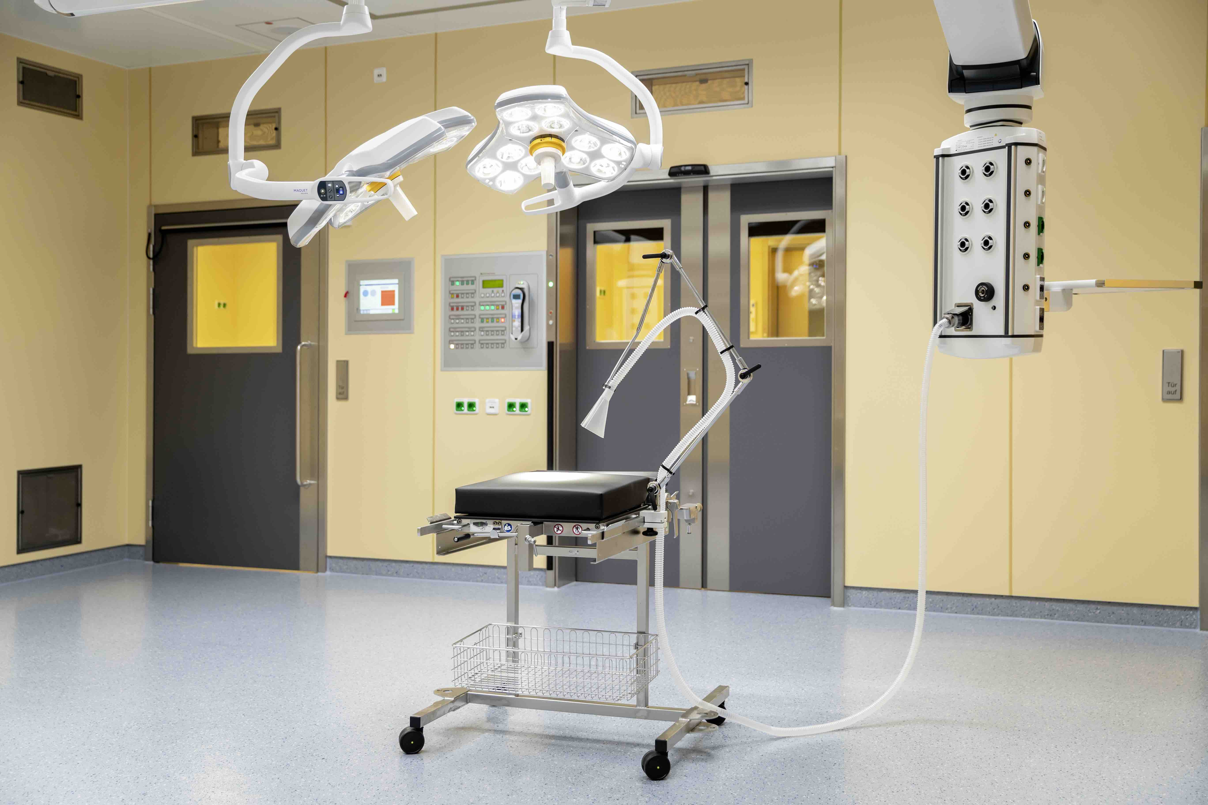
The permanently installed smoke extraction system reliably protects patients and staff from surgical smoke.

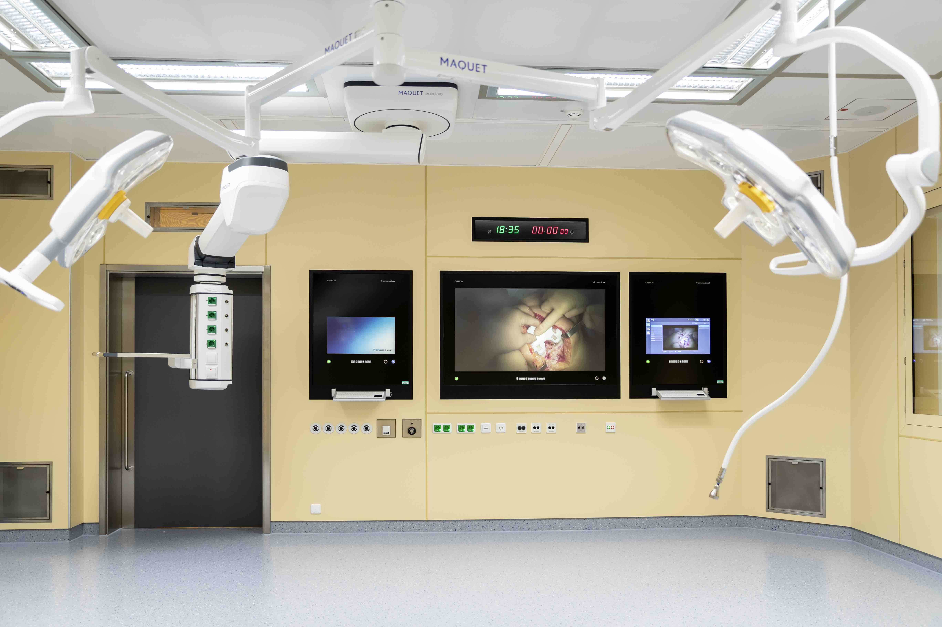
The aspiration tube for particle monitoring measures the particle content in the protective zone near the instrument table in real time.

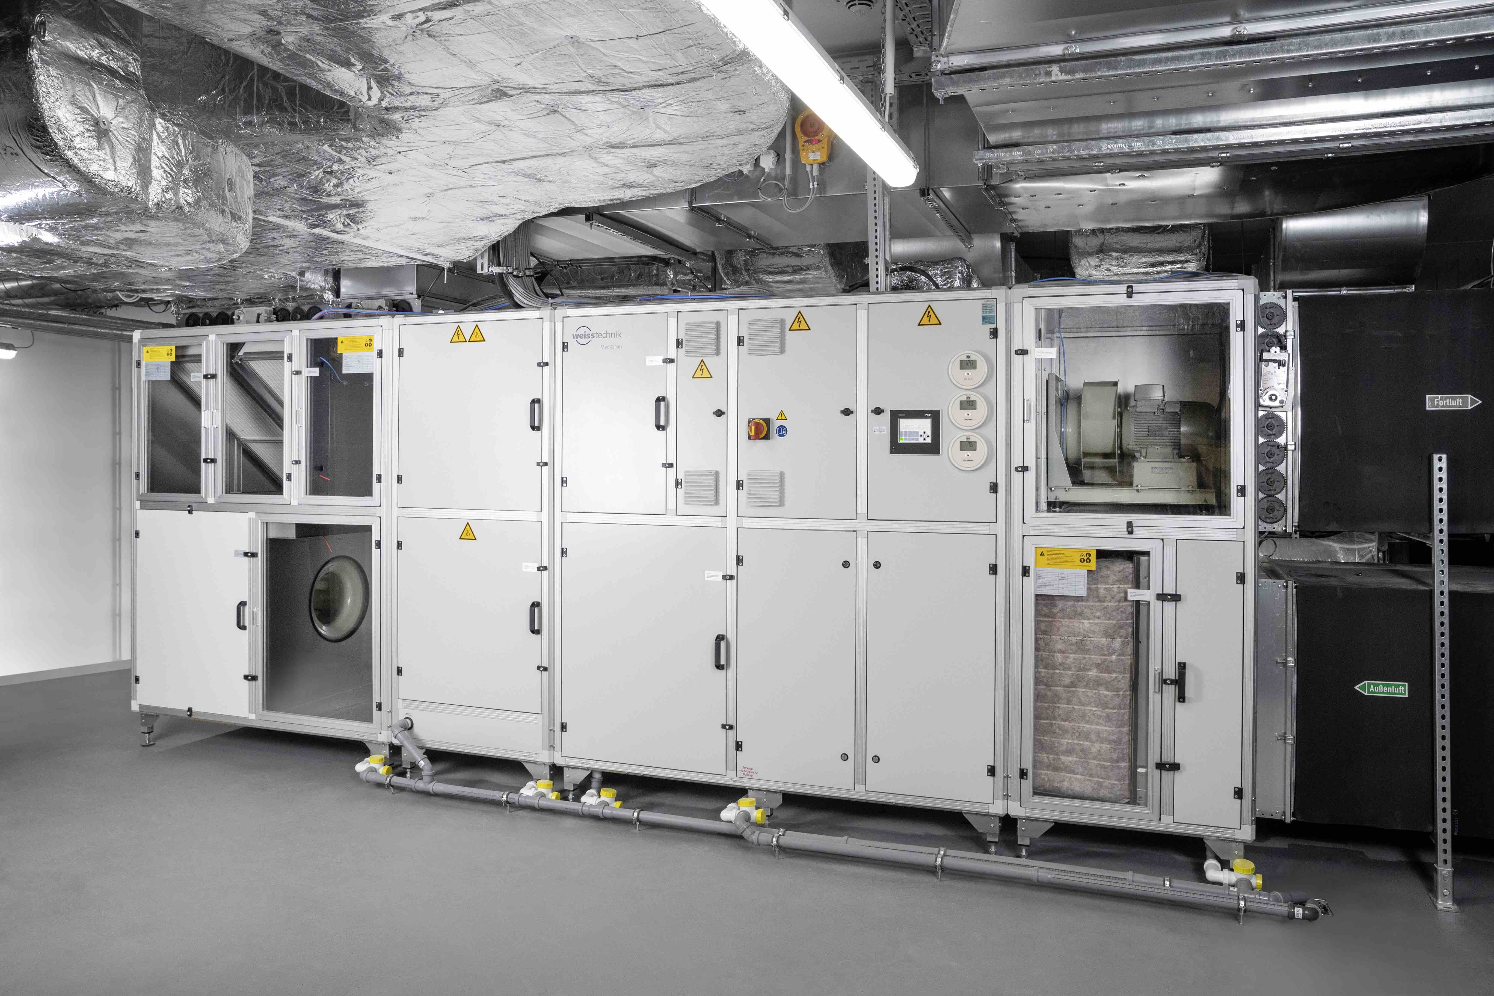
Space-saving and energy-efficient air-conditioning unit in the central air conditioning plant.

Weiss Technik companies
In line with the slogan – Test it. Heat it. Cool it. – the Weiss Technik companies provide solutions that are used around the world in both research and development as well as in production and quality assurance for numerous products. Our expert employees in over 22 companies in 15 countries at 40 sites provide ideal service support and ensure the high operational reliability of your systems. The products that bear the weisstechnik® brand include environmental simulation, heating, air-conditioning and containment solutions.
Weiss Klimatechnik provides reliable air-conditioning solutions wherever optimal climatic conditions for man and machine are required: in industrial production processes, cleanrooms and measuring rooms, hospitals, mobile operation tents or in the information and telecommunication technology fields. As one of the leading providers of professional cleanroom and air-conditioning systems, we provide you with effective and energy saving solutions, and support you with our expertise from the planning to the implementation of your projects. The Weiss Technik companies are part of the Schunk Group, which is based in Heuchelheim, close to Giessen. www.weiss-technik.com
Schunk Group
The Schunk Group is a globally operating technology company with a global business unit structure. The company is a leading supplier of products made of high-tech materials – such as carbon, technical ceramics and sintered metal – as well as machines and systems – from environmental simulation and air conditioning to ultrasonic welding and optical machines. The Schunk Group has more than 8,500 employees in 29 countries and achieved sales of €1.28 billion in 2018.
(5,623 characters incl. spaces)
May be reprinted free of charge. Please specify “Weiss Technik companies” as the source.

