Press release

Comfortable, safe, uniform
Contact
Marco Michels
Pressebeauftragter
Tel +49 641 58174-27
marco.michels.external@weiss-technik.com

Gerlinde Schowalter
Leitung Markenauftritt und PR
Tel +49 6408 84-6231
gerlinde.schowalter@weiss-technik.com

Weiss Klimatechnik GmbH
Greizer Straße 41-49
35447 Reiskirchen
Deutschland
www.weiss-technik.com

The new fitotron SGC insect and plant growing chambers

Reiskirchen, 19/03/2019 – weisstechnik sets new standards on the market with the fitotron SGC insect and plant growing chambers. The growing chambers ensure reproducible, uniform growth conditions, offer maximum growth height and optimal fitosafe air guiding and varied control and connectivity options. The optional webcam-based remote monitoring of the growing chamber is a highlight.
As a long-standing, reliable partner to laboratories and research facilities, weisstechnik has developed the new fitotron SGC growing chambers precisely to meet customer requirements. They offer precisely controlled, insect- and plant-friendly climate simulation, more convenient and safer operation, as well as a high level of flexibility in use.
Comprehensive standard equipment
Even in the standard version, the fitotron SGC growing chambers are designed to be perfect for up to four racks of Arabidopsis with a growing height of 133 cm. The optimal fitosafe air guiding system with adjustable air speed ensures even transpiration and a good exchange of CO₂ and O₂. Together with contamination-free humidification, fully desalinated water reliably prevents germ ingress.
Networking and multi-user control
The WEBSeason® Bio interface for easy networking and multi-user control is also included as a standard feature. The Internet connection allows up to five users to access, control or monitor the growing chamber simultaneously: one user at the chamber itself, and four others via PC, tablet or smartphone, for example. A clear 7" colour touch display is fitted as a control panel at an ergonomic working height on the growing chamber itself.
Webcam for remote monitoring
The growing chamber can be fitted with an optional webcam to monitor the plants and insects optimally at all times. It can be positioned freely, and even lets users perform quick visual inspections from home by PC and tablet.
Wide range of options, individual customisation
Other optional extras like high-efficiency fluorescent or LED lighting, a full demineralisation unit or a water-cooled refrigeration unit, allows the growing chambers to be equipped based on the requirements. They are available with one, two or three doors. Thanks to their variable features, they are ideal for different plants, insects and tissue cultures, as well as for drying and storing seeds.

Learn more about our fitotron SGC insect and plant growing chambers: www.weiss-technik.com

(2,645 characters incl. spaces)

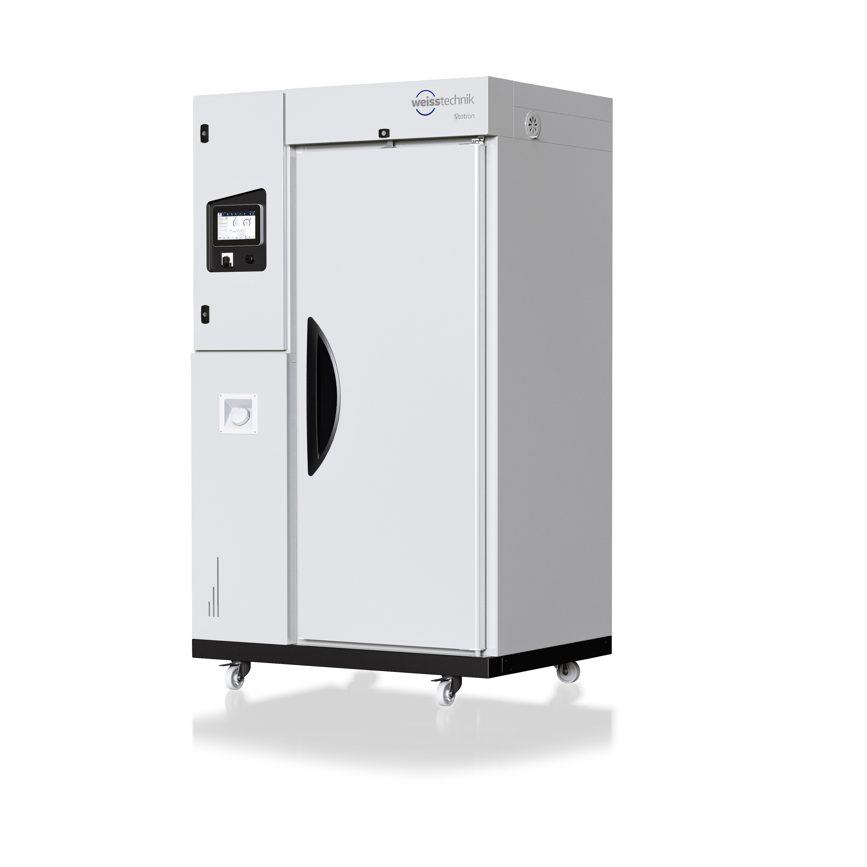

Abb. 1: The new fitotron SGC growing chambers are available with one, two or three doors.

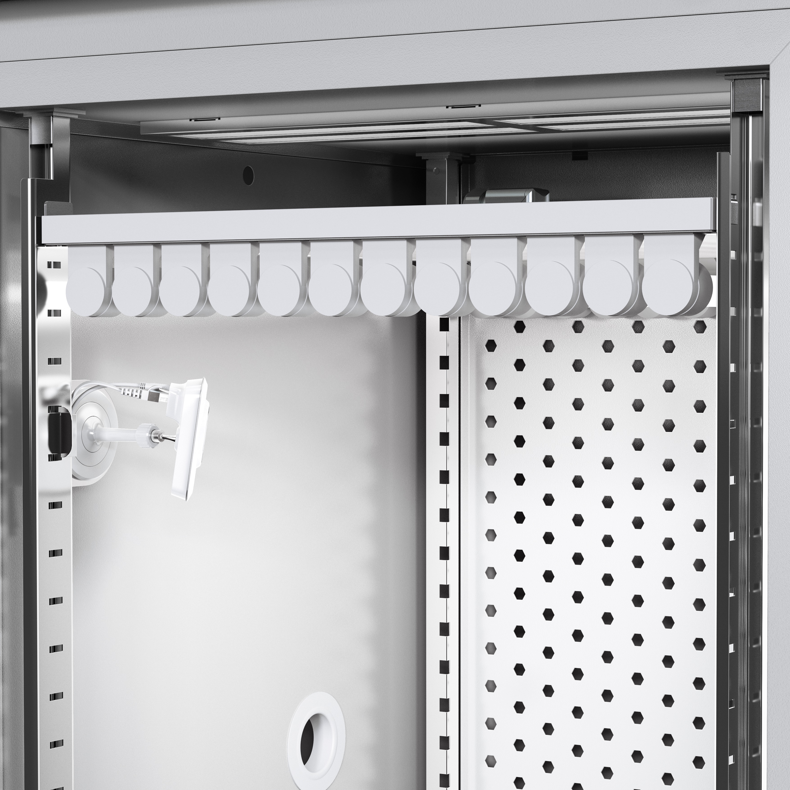
Abb. 2: The growing chamber can be fitted with an optional webcam to monitor the plants and insects optimally at all times.

Weiss Technik companies
In line with the slogan – Test it. Heat it. Cool it. – the Weiss Technik companies provide solutions that are used around the world in both research and development as well as in production and quality assurance for numerous products. Our expert employees in over 22 companies at 40 sites provide ideal service support and ensure the high operational reliability of your systems. Products that bear the weisstechnik® brand include solutions for environmental simulation, air-conditioning and containment. Various environmental conditions around the world can be simulated in an accelerated manner using our environmental simulation test systems. The functionality, quality, reliability, material durability and service life of the product to be tested are investigated under real loads. The dimensions of our test units range from laboratory test cabinets right through to test chambers for aviation components with a volume of several hundred cubic metres. The Weiss Technik companies are part of the Schunk Group, which is based in Heuchelheim, close to Giessen.
Schunk Group
The Schunk Group is an internationally active technology company with roughly 8,100 employees in 29 countries. The Group offers a wide range of products and services in the carbon technology and ceramics, environmental simulation and air-conditioning technology, sinter metals and ultrasonic welding sectors. In 2016, the Schunk Group generated a turnover of over 1.1 billion euros.
May be reprinted free of charge. Please specify “Weiss Technik companies” as the source.

