Press Release
Reiskirchen, Germany, 12.11.2019

Contact
Marco Michels
Press Officer
Tel.: +49 641 5817427
marco.michels.external@weiss-technik.com

Gerlinde Schowalter
Brand Identity and PR Manager
Tel.: +49 6408 846231
gerlinde.schowalter@weiss-technik.com

Weiss Umwelttechnik GmbH
Greizer Strasse 41–49
35447 Reiskirchen
Germany
www.weiss-technik.com

A premiere at productronica: the new S!MPATI® 4.70 control software for environmental simulation chambers

With a new design, optimised menu navigation and practical analysis options, weisstechnik is now presenting its new S!MPATI® 4.70 software generation. This new software was developed for the programming, monitoring and networking of climate test chambers. S!MPATI® 4.70 not only features the proven stability and compatibility of S!MPATI® software but also sets new standards in terms of operating efficiency and performance. With S!MPATI Online, the company will additionally provide a cloud-based extension for the automatic generation of test reports.

Visualisation clearer than ever before
S!MPATI 4.70 controls, archives and analyses tests. When doing so, the software offers a multitude of new features to make processes quicker, simpler and clearer. Examples of such features include the zoom and measurement functions of the new analysis tool and the possibility of using S!MPATI TimeLabs (optional) to integrate and/or export images from the test chamber. The optimised menu navigation is specifically designed to meet the needs and requirements in laboratory environments. Warnings and information are easy to access and can also be sent via e-mail. Where required, laboratory plans can be uploaded for realistic visualisation of the test equipment layout. The equipment overview then makes it easier for users to control, program and analyse all test chambers centrally from one computer.

Cloud-based data handling and test report generation
The storage of data in the Microsoft Azure Cloud offers future-oriented flexibility. It not only provides secure, decentralised and browser-based access to the data but also improves data security by providing an additional storage location. Web technologies enable automatic updates and users can also choose to save standardised procedures as a process. When generating test reports, the software provides access to a Word template (.docx) that conforms to all standards pursuant to IEC / DIN EN 60068-2-38 and can also be individually adapted at a later point in time.

The highest security and maximum compatibility
S!MPATI 4.70 is fully compatible with Windows 10 and is therefore an extremely future-proof solution. This is particularly important for laboratories planning to convert to Windows 10 because Microsoft will cease to provide support for Windows 7 as of 2020. S!MPATI 4.70 is suitable for all current weisstechnik devices and downwardly compatible with all models up to 1987. The software additionally enables the integration of third-party equipment.

Presentation at productronica 2019, available from 2020
S!MPATI 4.70 and S!MPATI Online will both be showcased for the first time at the productronica trade fair, which will take place in Munich from 12th to 15th November. They will be available from the beginning of 2020, when the software can be easily downloaded from the weisstechnik website and simply activated with a licence key. A data CD will also be available on request.

For more information, please visit www.weiss-technik.com or our booth # 239 in hall A2 at Productronica in Munich.

(3066 characters incl. spaces)

Reprint free of charge. Please specify Weiss Technik Companies as the source.

Figure 1:
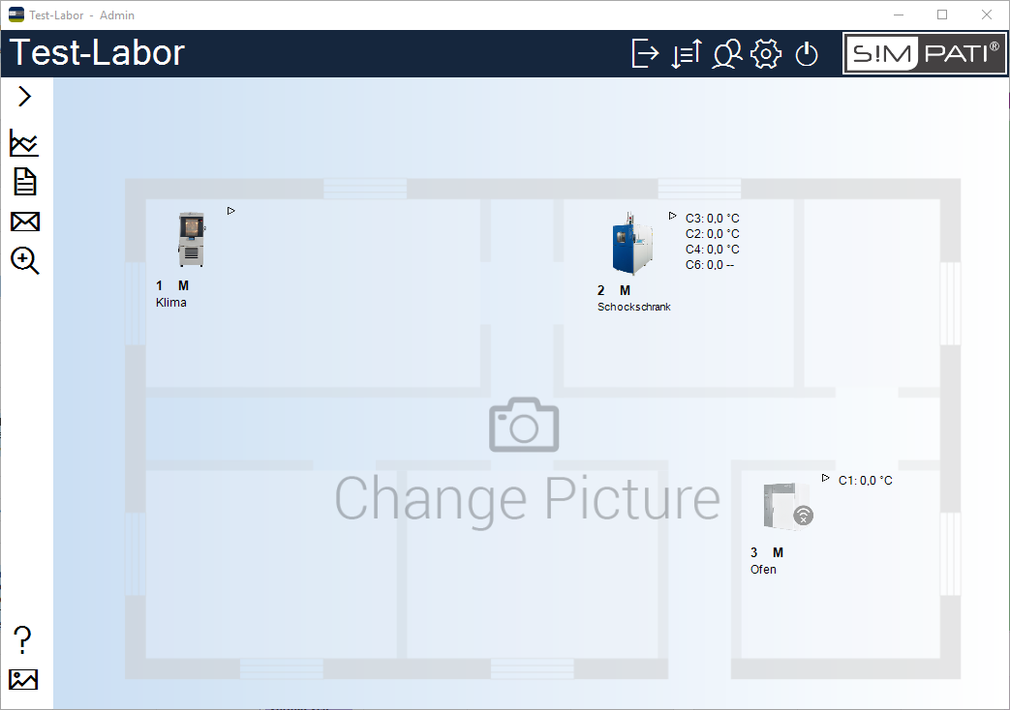
A new menu and navigation for an optimal overview of the laboratory

Figure 2:
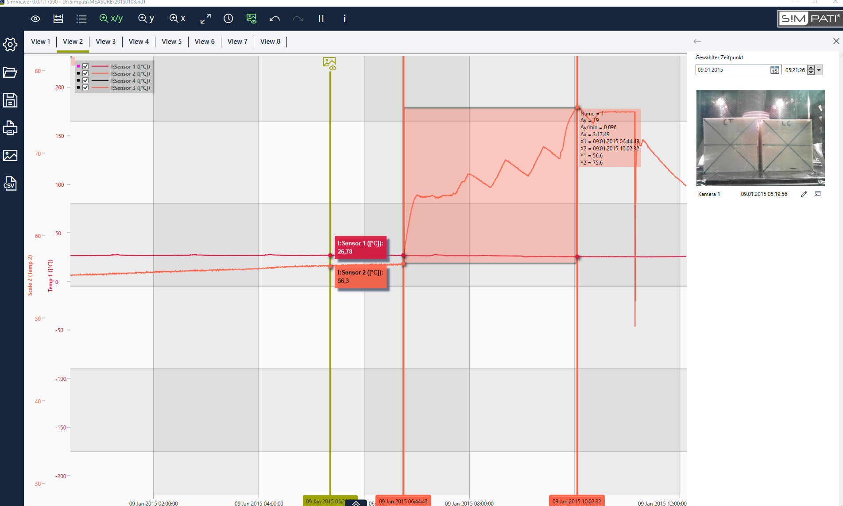
Stay up to date at all times with the S!MPATI TimeLabs function, available as an optional extra

Figure 3:
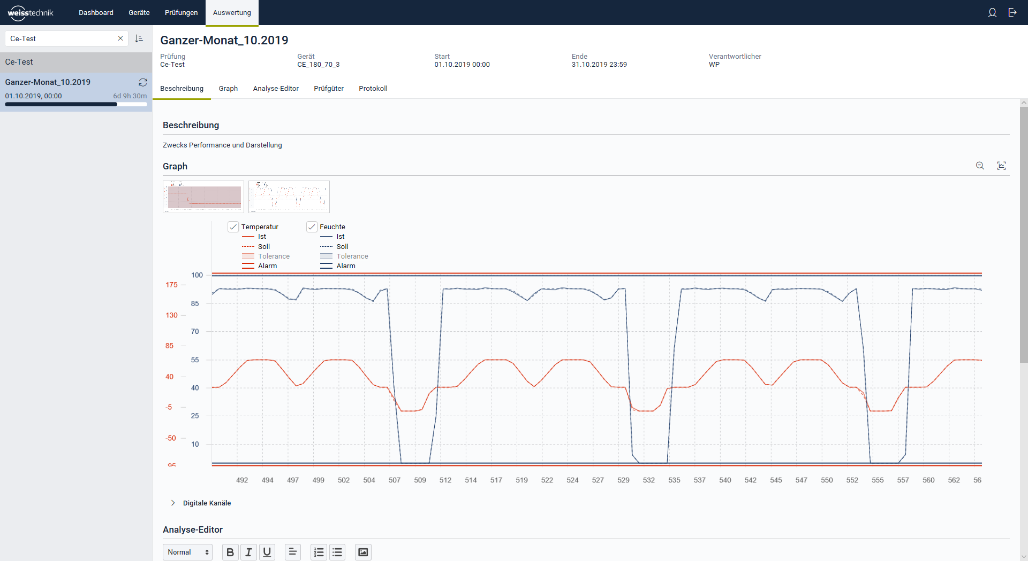
Clear analysis with S!MPATI® Online
The Weiss Technik Companies
Under the slogan “Test it. Heat it. Cool it.”, the Weiss Technik Companies offer solutions that are used around the world in research and development as well as in the production and quality assurance of numerous products. A strong distribution and service organisation with 22 companies at 40 locations in 15 countries ensures optimum customer support and guarantees a high degree of operational safety. The brand weisstechnik® includes individual solutions for environmental simulation, clean rooms, climatic engineering, air dehumidification and containment solutions. With its test systems from the field of environmental simulation, different environmental influences around the globe can be simulated in time-lapse mode. The product is tested under real load for its functionality, quality, reliability, material resistance and service life. The dimensions of the test equipment range from laboratory test cabinets to test chambers for aircraft components with a volume of several hundred cubic metres. The Weiss Technik Companies are part of the Schunk Group based in Heuchelheim near Gießen, Germany.

Schunk Group
The Schunk Group is a globally operating technology company with a global business unit structure. The company is a leading supplier of products made of high-tech materials – such as carbon, technical ceramics and sintered metal – and machines and systems – from environmental simulation and air conditioning to ultrasonic welding and optical machines. The Schunk Group has more than 8500 employees in 29 countries and achieved sales of €1.28 billion in 2018.

