Press Release
Reiskirchen, Germany, 12.11.2019

Contact
Marco Michels
Press Officer
Tel.: +49 641 5817427
marco.michels.external@weiss-technik.com

Gerlinde Schowalter
Brand Identity and PR Manager
Tel.: +49 6408 846231
gerlinde.schowalter@weiss-technik.com

Weiss Umwelttechnik GmbH
Greizer Strasse 41–49
35447 Reiskirchen
Germany
www.weiss-technik.com

WT69 is given the number R-469A
ASHRAE certifies the new refrigerant

With WT69, weisstechnik has developed an alternative to R23 with a GWP reduced by 90%. WT69 has now been certified as a Class A1/A1 refrigerant. When it comes to the testing and certification of new refrigerants, the American Society for Heating and Air-Conditioning Engineers (ASHRAE) is the globally recognised authority. By certifying the new refrigerant, the society has confirmed that WT69 is non-flammable and non-toxic, even in the case of leakage. WT69 will be given the number R-469A (publication pending) and will be launched on the market in November.

Official recognition by means of a verification process
The new WT69 / R-469A refrigerant was developed in order to offer an alternative to R23 with a much lower GWP for use in deep-freeze applications. The certification by ASHRAE confirms the success of the development work and was awarded to the refrigerant after an intensive test conducted by an expert panel and the end of the period for objection. For operators of environmental simulation systems, the certification above all acts as evidence that the refrigerant is future-proof with regard to the next stage of the F-gas Regulation. WT69 / R-469A has a GWP of 1357 and will be freely available on the market from the end of the year. The Head of Marketing, Steffen Hönlinger, states that: “We are delighted about the certification, which rewards our commitment. With the R-number, we have received a seal of approval that is understood as a sign of safety and reliability across different sectors and industries.”

Freely available on the market from November
WT69 / R-469A was developed by weisstechnik in close cooperation with Dresden University of Technology. By the end of the year, it will be used in all compact ClimeEvent standard climate test chambers with a cooling rate of between 3 and 5 Kelvin. From 2020, special models such as vibration cabinets and climate test chambers with temperature-changing rates of up to 20 Kelvin will also change over to this new refrigerant. From the end of November, WT69 / R-469A will be independently produced and freely distributed by the company Technische Gase und Gastechnik GmbH (TEGA) in the German city of Würzburg. TEGA will ensure the safe and professional handling of the refrigerant from production through to filling and right through to sales and transport. Janko Förster, Head of Product Management at Weiss Umwelttechnik, explains that: “By working with TEGA, we are pleased to have found a reliable and experienced partner with a corresponding distribution network that will help us to firmly establish WT69 / R-469A in the market.”

The quota system for R23 means that a new refrigerant is needed
The refrigerant regulation for fluorinated greenhouse gases significantly tightens the restrictions placed on manufacturers of systems using FC refrigerants. It also stipulates new requirements for operators of existing systems with regard to their testing and documentation obligations. At the same time, R23 will also become scarcer and more expensive due to the quota system. As one of the world’s leading specialists for environmental simulation testing systems, weisstechnik identified these impacts at an early stage and started to develop a synthetic refrigerant for deep-freeze systems. With WT69 / R-469A, Weiss weisstechnik now presenting a fully-fledged alternative to R23 with a GWP reduced by 90%. The new refrigerant requires no compromise in terms of performance, use and cost-effectiveness, reliably delivers comparable test results and allows the further use of existing test profiles. WT69 / R-469A is therefore an extremely future-proof solution and a secure investment.

For more information, please visit www.weiss-technik.com or our booth # 239 in hall A2 at Productronica in Munich.

(3781 characters incl. spaces)

Reprint free of charge. Please specify Weiss Technik Companies as the source.

Image 1: Conversion/servicing
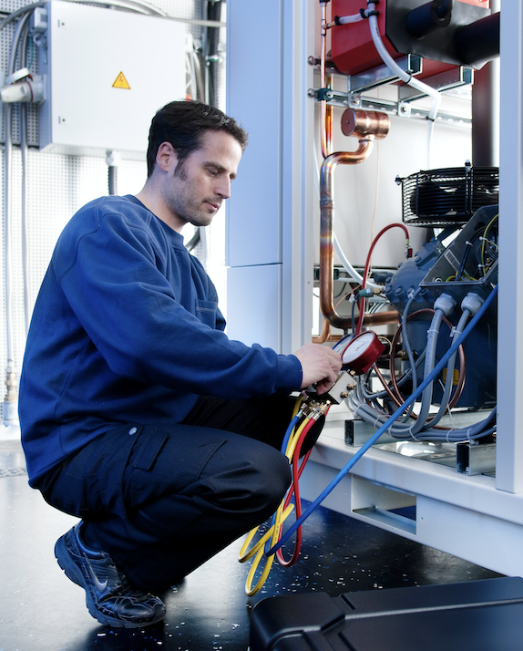
The conversion of existing systems to WT69 / R-469A is an easy
process carried out by qualified weisstechnik service specialists.

Image 2: ClimeEvent models
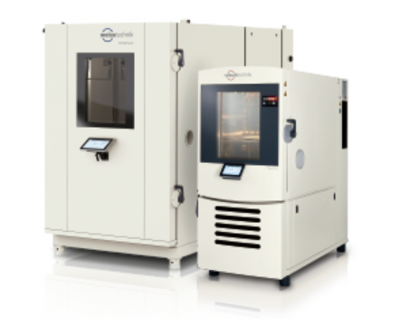
ClimeEvent test chambers containing WT69 / R-469A will continue to provide reliable and legally compliant tests in an extended temperature range down to -70°C.

Image 3: Overview
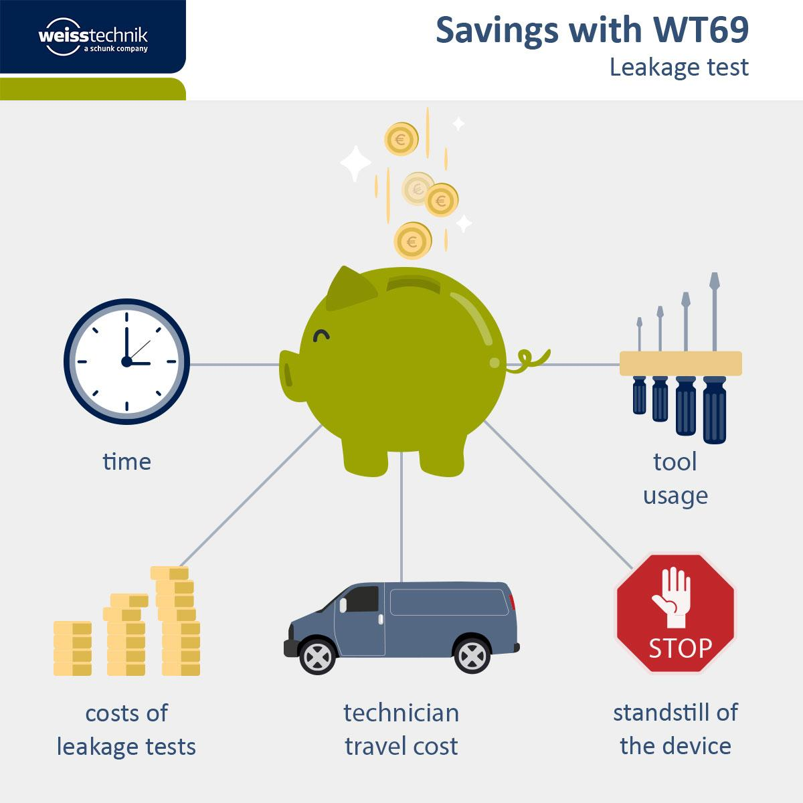

WT69 / R-469A offers a wide variety of potential savings in
low-temperature tests at temperatures down to -70°C.

Image 4: Janko Förster
Janko Förster, Head of Product Management at Weiss Umwelttechnik,
is pleased about the successful ASHRAE certification of WT69 / R-469A.

The Weiss Technik Companies
Under the slogan “Test it. Heat it. Cool it.”, the Weiss Technik Companies offer solutions that are used around the world in research and development as well as in the production and quality assurance of numerous products. A strong distribution and service organisation with 22 companies at 40 locations in 15 countries ensures optimum customer support and guarantees a high degree of operational safety. The brand weisstechnik® includes individual solutions for environmental simulation, clean rooms, climatic engineering, air dehumidification and containment solutions. With its test systems from the field of environmental simulation, different environmental influences around the globe can be simulated in time-lapse mode. The product is tested under real load for its functionality, quality, reliability, material resistance and service life. The dimensions of the test equipment range from laboratory test cabinets to test chambers for aircraft components with a volume of several hundred cubic metres. The Weiss Technik Companies are part of the Schunk Group based in Heuchelheim near Gießen, Germany.

Schunk Group
The Schunk Group is a globally operating technology company with a global business unit structure. The company is a leading supplier of products made of high-tech materials – such as carbon, technical ceramics and sintered metal – and machines and systems – from environmental simulation and air conditioning to ultrasonic welding and optical machines. The Schunk Group has more than 8500 employees in 29 countries and achieved sales of €1.28 billion in 2018.

