Press release
Contact
Weiss Pharmatechnik GmbH
Georg-Bölts-Straße 2-8
26135 Oldenburg
Tel. +49 441 57054-0
info.pharma@weiss-technik.com
www.weiss-technik.com

Marketing
Elke Weber
Tel. +49 441 57054-196
elke.weber@weiss-technik.com

Safety and comfort with 60% less exhaust air
The new workstation

Oldenburg, 19/08/ 2019 – The best possible protection has to be provided for people and the surrounding area whenever work involves active substances and hazardous materials. The innovative workstation sets new standards when it comes to safe workplaces for laboratories, and is now even more efficient and easy to use. The specialised airflow principle and table extraction system provides a consistently high level of protection for both people and the surrounding area.
Using the know-how of the industry expert
It is particularly important to use safety workplaces to protect employees, products and the surrounding area whenever hazardous substances are involved: that includes laboratories, institutes and pharmaceutical companies, in addition to associated research and commercial sectors. As a long-standing industrial partner, Weiss Pharmatechnik provides solutions which are tailor-made to meet the demanding requirements imposed by the working and manufacturing conditions which are prevalent in the pharmaceutical and chemical sectors. With the new workstation, this begins with the design based on DIN EN 14175-2, and continues through to the workstation ergonomics and the financial aspects of the system.
Safe and ecologically friendly: table extraction and integrated filters

The workstation uses a special extraction and filtration principle which reliably prevents hazardous materials from reaching the surrounding area. This is achieved by creating an air curtain at the front of the workstation. The air curtain traps dangerous substances like gases or airborne product particles. A table extraction system guides the substances directly to the filters in the frame. This prevents the accumulation of hazardous substances in the extraction system, reduces the amount of cleaning required and protects the environment.

Smart air recycling cuts costs

The workstation only produces around 250 m³/h of exhaust air, around 60% less than traditional laboratory fume hoods. This significantly reduces the cost of running the building’s extraction system. This is made possible by a partial air recirculation system which recirculates around 1/3 of the filtered and purified exhaust air and forms the protective air curtain in front of the work area. The remaining exhaust air is discharged through the building’s exhaust system. The result: a consistently small amount of exhaust air, even when the front sash is open. This also makes it possible to use multiple safety workstations at the same time in a laboratory with limited exhaust air capacity.

Personal protection which meets requirements

The workstation provides tested operator protection in accordance with DIN EN 14175-3 and has a robust retention capacity. An exposure test performed in accordance with SMEPAC guidelines measured an outbreak < 10 mg/m³ air. As a result, the workstation can be used to work safely with active substances and hazardous materials. A gas detector detects the saturation level of the activated carbon filter. The collection tray can also be fitted with a fluid sensor, which can trigger an alarm in the event of an incident.

Bright, spacious and comfortable

The sophisticated ergonomic design of the workstation ensures pleasant working conditions. The integrated LED light provides for a bright and evenly lit workstation. The slim frame means that work can also be carried out in a seated position. The generous amount of usable height, width and depth, combined with a maximum front sash opening of 700 mm, means that even large containers and laboratory equipment are easily accommodated. Additional comfort is provided by the quiet, draft-free operation of the system.

Options for a range of possibilities

The workstation can be fitted with different filters and combinations of filters to meet customer requirements. These include activated carbon filters for general chemistry, HEPA and activated carbon filters for powdery active substances and special filters for reactive reagents. The media column can also be equipped according to individual requirements with up to 6 media modules - such as electricity, argon, nitrogen, compressed air, vacuum and cooling water.

Opens and closes automatically

The front sash can be manual or electric, depending on your requirements. The electric version has a light barrier which automatically stops the movement of the sash if an obstacle is detected. A presence sensor is used to monitor the work area. If it is vacated, the front sash lowers automatically after an adjustable amount of time, and the workstation will switch to its cost-saving standby mode.

More information about the special laboratory fume hood Workstation is available at www.weiss-technik.com.
(4,783 characters incl. spaces)
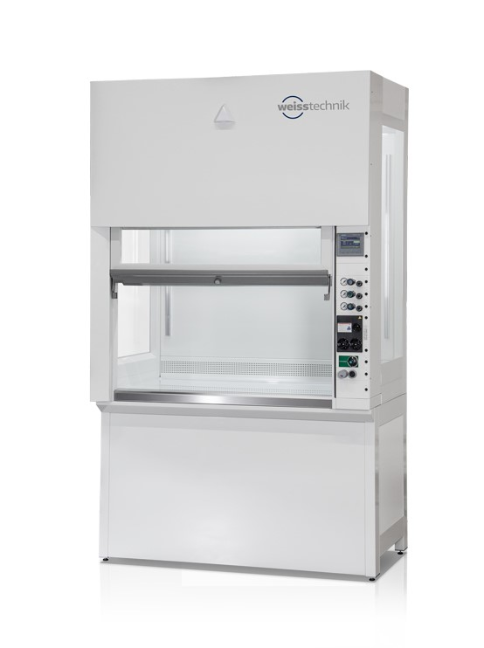
Bildmaterial:

Fig. 1: Even with the sash open, the exhaust air volume of the workstation remains constantly low at only 250 m³/h.

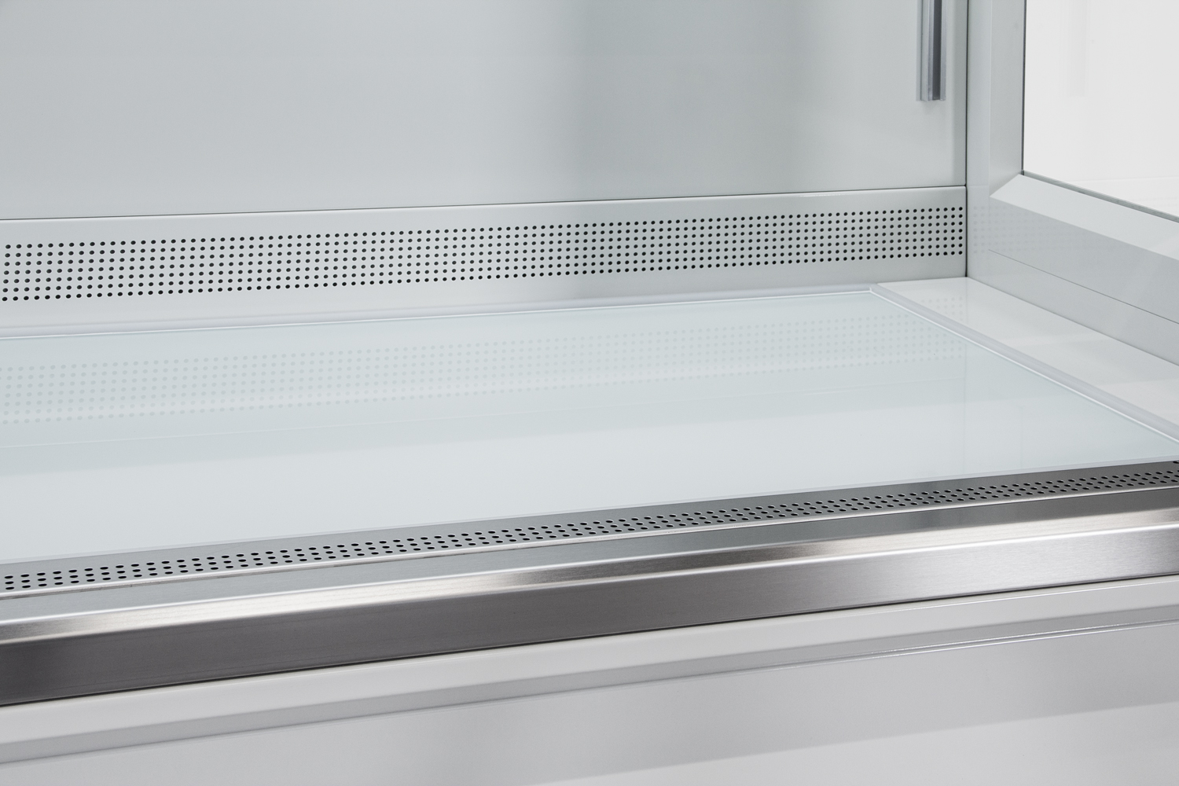

Abb. 2: Extraction and filter technology are integrated in the base frame. The exhaust air cleaning system enables cost-saving partial recirculation operation.
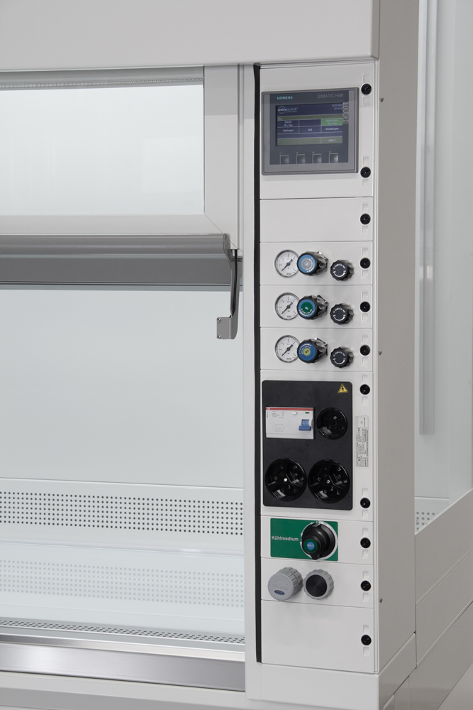

Abb. 3: The media column can be equipped with up to 6 modules as required, such as sockets, Ethernet connections, gas, vacuum and cooling water fittings.

May be reprinted free of charge. Please specify “Weiss Technik companies” as the source.

Weiss Technik companies
In line with the slogan – Test it. Heat it. Cool it. – the Weiss Technik companies provide solutions that are used around the world in both research and development as well as in production and quality assurance for numerous products. Our expert employees in over 22 companies at 40 sites provide ideal service support and ensure the high operational reliability of your systems. Products that bear the weisstechnik® brand include solutions for environmental simulation, air-conditioning and containment.
The Weiss Technik companies are part of the Schunk Group, which is based in Heuchelheim, close to Giessen. www.weiss-technik.com

Schunk Group
The Schunk Group is a globally operating technology company with a global business unit structure. The company is a leading supplier of products made of high-tech materials – such as carbon, technical ceramics and sintered metal – as well as machines and systems – from environmental simulation and air conditioning to ultrasonic welding and optical machines. The Schunk Group has more than 8,200 employees in 29 countries and achieved sales of about €1.2 billion in 2017.

