Press Release
12 November 2019

Contact
Marco Michels
Press Commissioned
Tel +49 641 58174-27
marco.michels.external@
weiss-technik.com

Gerlinde Schowalter
Head of Brand Design & PR
Tel +49 6408 84-6231
gerlinde.schowalter@
weiss-technik.com

Weiss Umwelttechnik GmbH
Greizer Straße 41-49
35447 Reiskirchen
Germany
www.weiss-technik.com

vötschtechnik – innovative Industrial Laboratory Ovens Lab for highly precise and reproducible heat treatments

Robust Industrial Laboratory Ovens are basic equipment in productions, quality assurances as well as research and development. weisstechnik® presents a new generation of reliable and well-equipped Laboratory Ovens under the brand vötschoven. These ovens work highly precise, reproducible and very energy-efficiently. Three standard sizes feature a processing chamber volume between 60 and 200 litres. The ovens are available in three stock lines.

Robust construction, futureproof technology
The ovens are designed especially for heavy-duty applications in industrial environments, requiring robust constructions. They are ideal for applications requiring high precision temperature control in the range between +50 and +300 °C, guaranteeing reproducible, reliable results. Due to a control box in IP54, they are optimally suited for operations with dust and splash water. The interior housings are made of stainless steel, type 1.4301 (ANSI 316) and thus offer maximum corrosion protection. Industrial Laboratory Ovens can be integrated into the industry 4.0 world at any time. An especially adapted PID temperature controller features an Ethernet interface running the TCP/IP protocol. Network connectivity and process documentation are achieved e.g. by the S!MPATI® software. The reliable, tested controller package additionally features programming, timer and alarm functions.

Three stock lines fit any requirements
The new Industrial Laboratory Ovens Lab are available in three stock lines – leaving no serial wish unfulfilled. Already the version Basic offers numerous features for typical routine tasks and applications. Acquire additional sensible features ideal for many process and testing tasks with the version Premium from the beginning. The version Premium Plus adds a very strong exhaust air fan to the oven. This allows for substantially higher air exchange rates, e.g. for high moisture levels if a lot of condensate is expected or fast cooling is required.

Small Footprint, wide variety of uses
The ovens can be used as heating and drying ovens. Three standard sizes feature a processing chamber volume of 60, 100 and 200 litres. Thus, they perfectly fit the needs in the automotive and aerospace industries, the electronics and bio-pharmaceutical industries as well as in university research laboratories. The ovens can be used for product development, quality testing and thermal ageing. Due to their very high temperature accuracy they are suitable also for standard-compliant testing. An additional factory or even DAkkS calibration ensures enhanced testing and documentation safety. We are accredited for this purpose, in both service and quality assurance.

Ideal replacement for old units
If laboratory ovens are counting lots of years, a replacement will always pay off. The new Industry Laboratory Ovens feature innovative, future-proof equipment, offering the same interior dimensions as current Heraeus series 6000 units. This way, they simply replace old laboratory ovens without hassle. All Industrial Laboratory Ovens meet the requirements of the Machinery Directive (declaration of conformity to Machinery Directive 2006/42/EC) and therefore may be installed in production environments in any case.

For more information: www.voetsch-ovens.com or
productronica 2019 in Munich; Hall A2, Booth 239

(Characters with spaces: 3,321)

Reprint free of charge. Please specify as source Weiss Technik Companies

Photo material:

Image 1: voetschoven Lab

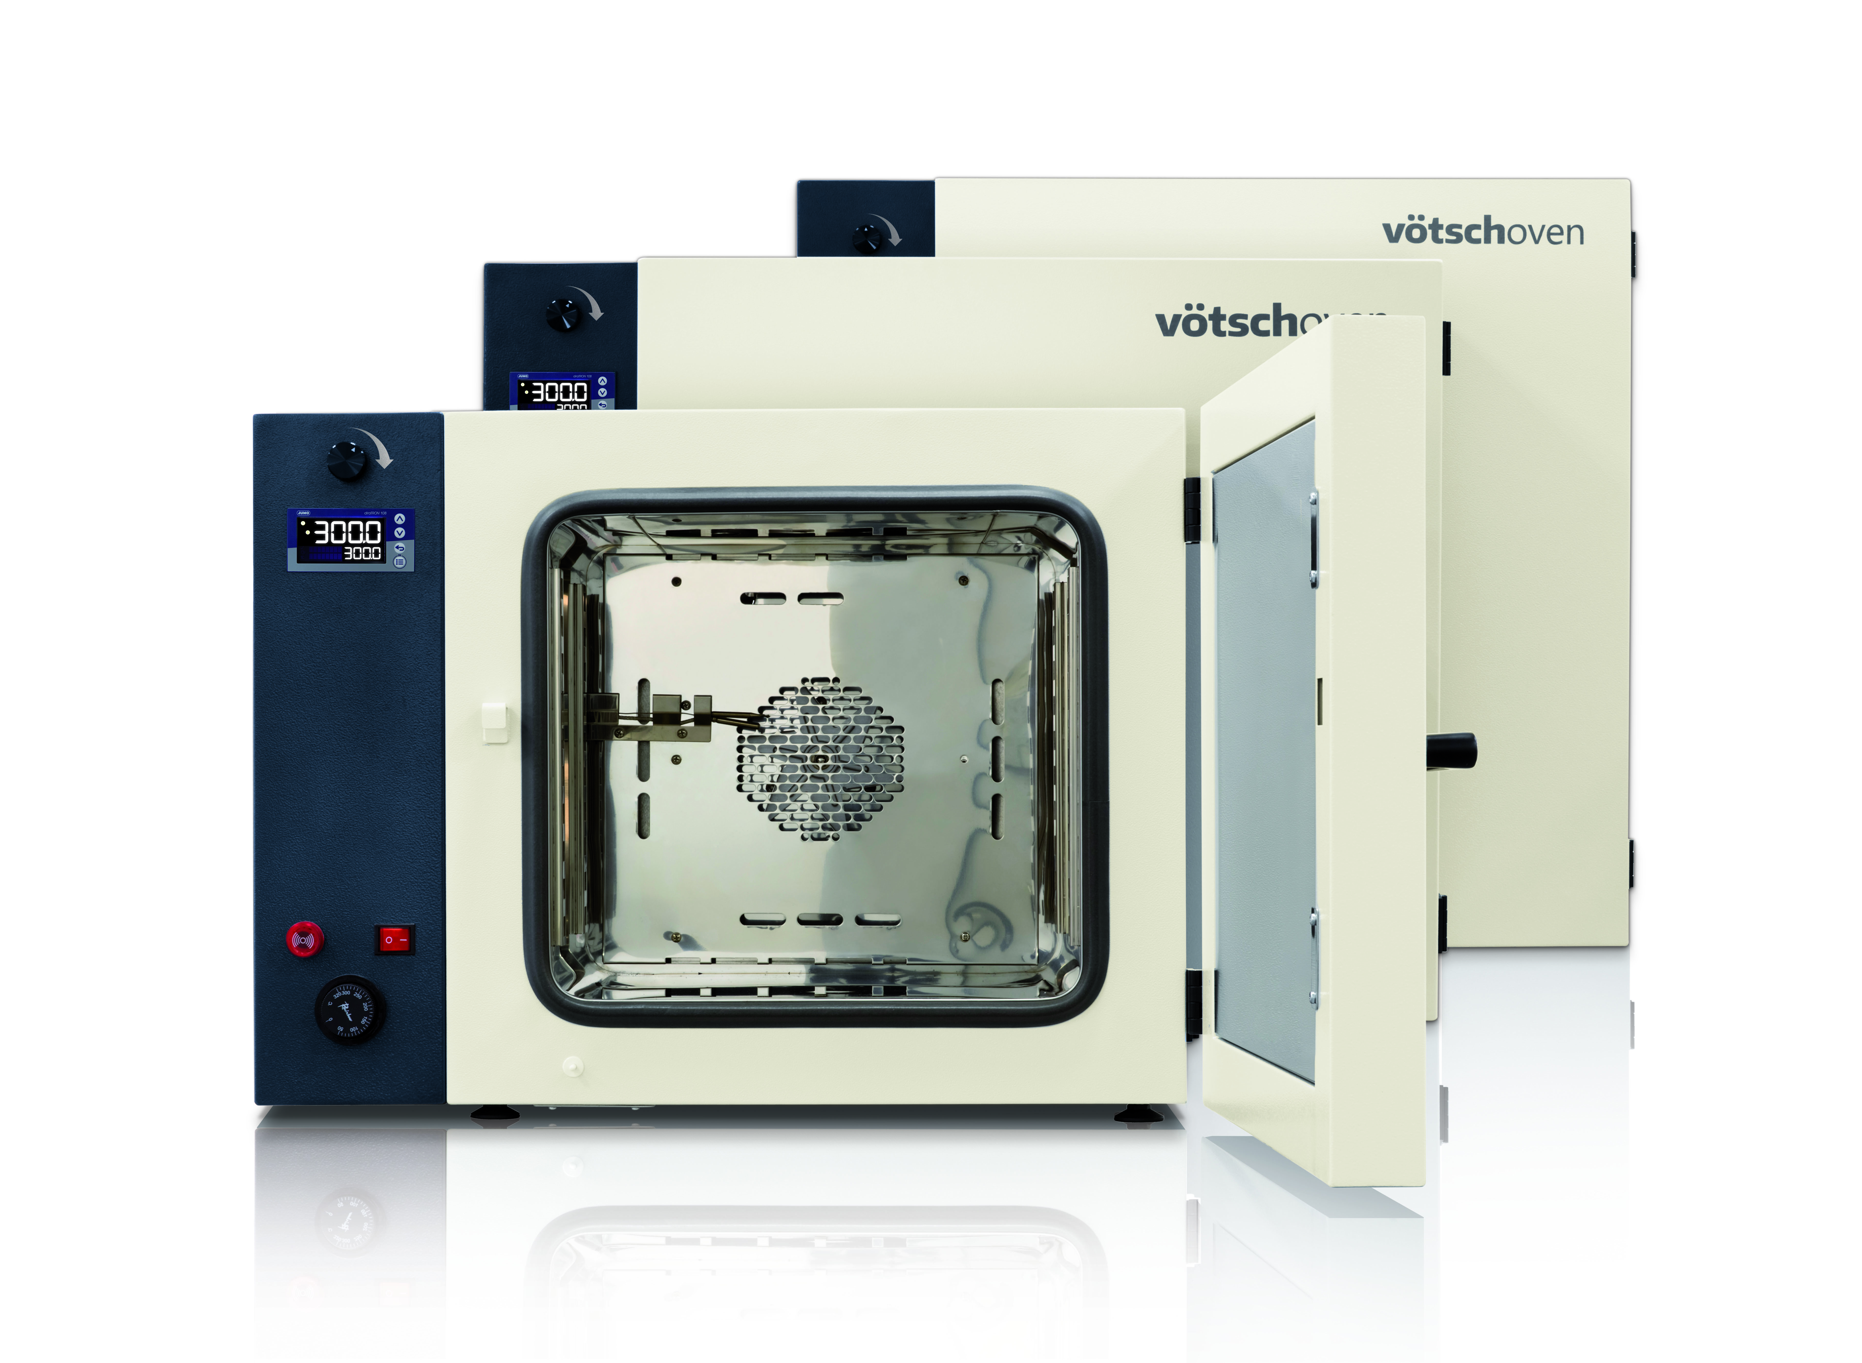

Image 2: voetschoven Lab

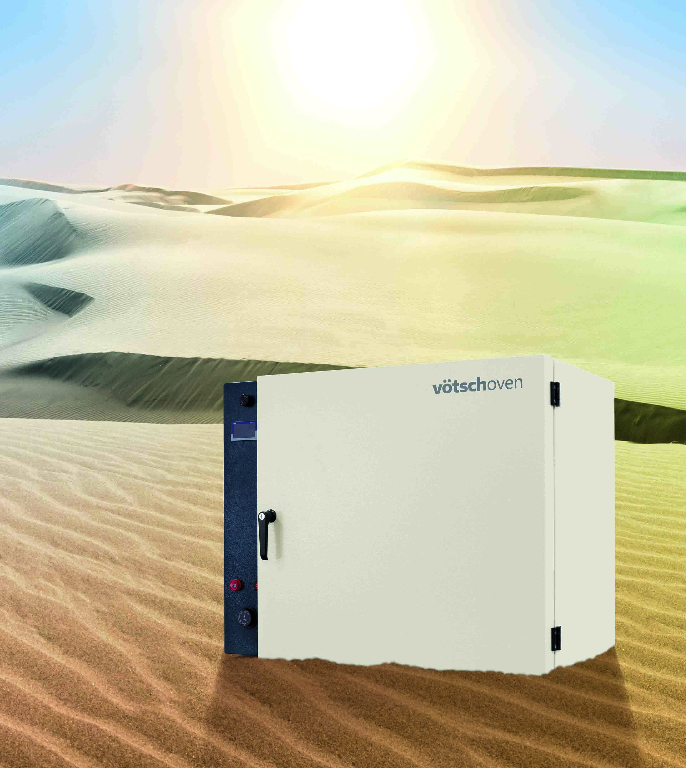

Image 3: voetschoven Lab

The Weiss Technik Companies
The Weiss Technik Companies offer under the slogan - Test it. Heat it. Cool it. - solutions that are used around the world in research and development as well as in the production and quality assurance of numerous products. A strong distribution and service organisation with 22 companies in 15 countries at 40 locations ensures optimum customer support and guarantees a high degree of operational safety. The brand weisstechnik® includes individual solutions for environmental simulation, heat technology, clean rooms, climatic engineering, air dehumidification as well as containment solutions.
An experienced team of engineers and designers develops, plans and produces high-quality and reliable heating technology systems for virtually any field of application. The wide product portfolio includes heating/drying ovens, clean room drying ovens, hot-air sterilisers, microwave systems and industrial ovens. The portfolio reaches from technologically sophisticated standard versions to customised solutions for individual production operations. The Weiss Technik Companies are part of the Schunk Group based in Heuchelheim near Gießen, Germany.

Schunk Group
The Schunk Group is a globally operating technology company with a global business unit structure. The company is a leading supplier of products made of high-tech materials – such as carbon, technical ceramics and sintered metal – as well as machines and systems – from environmental simulation and air conditioning to ultrasonic welding and optical machines. The Schunk Group has more than 8,500 employees in 29 countries and achieved sales of €1.28 billion in 2018.

