Press release
Reiskirchen, 09.06.2020

Contact details
yes or no Media GmbH
Claudia Wörner
Vor dem Lauch 4
D - 70567 Stuttgart
Tel +49 711 75 85 89 00
claudia.woerner@yes-or-no.de
www.yesorno.de

Weiss Klimatechnik GmbH
Anika Adams
Greizer Straße 41-49
D - 35447 Reiskirchen
Tel +49 6408 84 6842
anika.adams@weiss-technik.com
www.weiss-technik.com

Vindur® CoolMaster DX iFC air conditioning unit from weisstechnik
Cooler for server rooms under new flag

The Vindur® CoolMaster DX iFC works both with indirect free cooling and with mechanical direct evaporation. As a result, the precision air conditioning unit achieves the highest possible energy savings, even for larger data centres. The scalable Vindur® CoolMaster DX iFC is the first innovation presented by weisstechnik under the “Vindur” brand.

With new product names, weisstechnik is designing its range of air conditioning technology more clearly. The server air conditioning units will be renamed Vindur® CoolMaster. The first product launch in the current product range is the Vindur® CoolMaster DX iFC precision air conditioning unit. This reduces energy costs by combining two cooling systems. Whenever possible, it uses cold outside air by indirect free cooling. If the ambient temperature is too high, mechanical cooling takes place with water-cooled direct evaporation.

Due to the simple scalability and free installation, the energy-saving air conditioning technology can be used in server rooms. Further air conditioning units can be installed easily and quickly. Furthermore, the Vindur® CoolMaster DX iFC is available in three sizes. And so the new precision air conditioning units from weisstechnik are energy efficient, scalable and flexible at the same time.

The control system is also a highlight: Up to 16 devices can be operated in a redundancy network. This allows the control system to start up devices if an operating error occurs in another one. The intelli.4 control system is autonomous and offers flexible networking options.

1,628 characters (including spaces)

For more information visit www.weiss-technik.com
Reprint free of charge. Please state Weiss Technik companies as a source.

Picture:

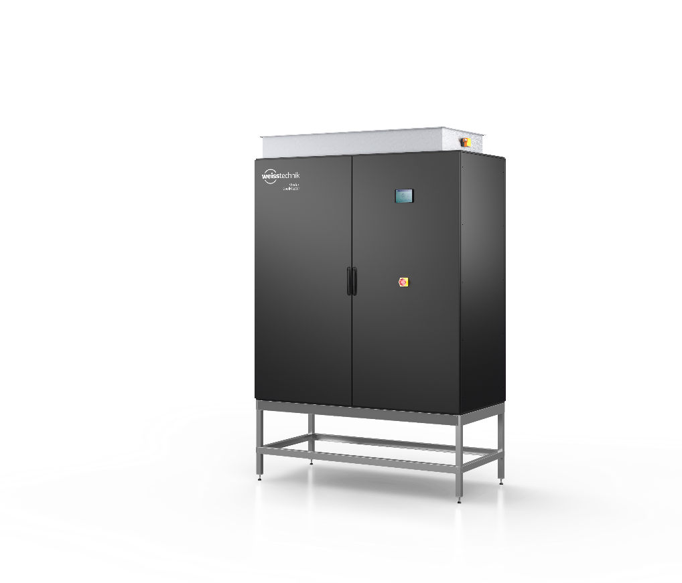
Picture 1: Weiss Klimatechnik GmbH
With new product names, weisstechnik is designing its range of air conditioning technology more clearly. The server air condition-ing units will be renamed Vindur® CoolMaster.

The Weiss Technik Companies
Under the slogan “Test it. Heat it. Cool it.”, the Weiss Technik Companies offer solutions that are used around the world in research and development as well as in the production and quality assurance of numerous products. A strong distribution and service organisation with 22 companies at 40 locations in 15 countries ensures optimum customer support and guarantees a high degree of operational safety. The brand weisstechnik® includes individual solutions for environmental simulation, clean rooms, climatic engineering, air dehumidification and containment solutions.
Weiss Klimatechnik provides reliable air-conditioning solutions wherever optimal climatic conditions for man and machine are required: in industrial production processes, clean rooms and measuring rooms, hospitals, mobile operation tents or in the information and telecommunication technology fields. As one of the leading providers of professional clean room and air-conditioning systems, we provide you with effective and energy saving solutions, and support you with our expertise from the planning to the implementation of your projects. The Weiss Technik companies are part of the Schunk Group, which is based in Heuchelheim, close to Giessen.

Schunk Group
The Schunk Group is a globally operating technology company with a global business unit structure. The company is a leading supplier of products made of high-tech materials – such as carbon, technical ceramics and sintered metal – and machines and systems – from environmental simulation and air conditioning to ultrasonic welding and optical machines. The Schunk Group has more than 9.100 employees in 29 countries and achieved sales of €1.35 billion in 2019.

