Press release
Reiskirchen, 10.06.2020

Contact details
yes or no Media GmbH
Claudia Wörner
Vor dem Lauch 4
D - 70567 Stuttgart
Phone +49 711 75 85 89 00
claudia.woerner@yes-or-no.de
www.yesorno.de

Weiss Umwelttechnik GmbH
Anika Adams
Greizer Straße 41-49
D - 35447 Reiskirchen
Phone +49 6408 84 6842
anika.adams@weiss-technik.com
www.weiss-technik.com

Campaign “For a safe future”
Secure your future with weisstechnik

With the campaign “For a safe future”, weisstechnik demonstrates its solutions for a safe future. The company bundles its comprehensive knowledge in user reports, interviews and product presentations.

weisstechnik is considered a hidden champion: mostly unnoticed, the company changes the world with its products. The company is now emerging from this shadow with the “For a safe future” campaign. Security, stability and predictability in all areas of life - for weisstechnik these are the prerequisites for a safe future.

A specially created online presence uses numerous examples to show how weisstechnik and its solutions make the world safer. The specialist for environmental, air-conditioning, heating and pharmaceutical technology draws on many years of experience. The company is known for its reliable products and outstanding performance.

Convincing product tests
Equipment and systems for environmental simulation support companies in the development of safe products: Because these often have to function reliably for years under extreme conditions, like batteries or airbags. The aerospace and medical technology industry also relies on weisstechnik’s many years of know-how for tests, for example for drug stability tests.

Safe environment
The corona pandemic currently shows how important clean air is. Special air conditioning units from weisstechnik free the air from bacteria and viruses. They are used in hospitals and operating rooms. In future, the devices will also be important in waiting rooms and public buildings. The company also has a wealth of experience in setting up cleanrooms in production, for example for food: Bacteria are reliably killed off in microwave disinfection chambers. Fuel temperature control systems and solutions for the reliable air conditioning of plant growth cabinets as well as operating theatres, or kitchen and crew tents in the defence sector are further examples that will become even more important in future.

Reliable production
weisstechnik also improves safety in production: Air guidance systems, for example, prevent employees from coming into contact with harmful substances, whilst extraction systems prevent contact with hot process vapours.

In the heat technology segment, weisstechnik builds reliable industrial furnaces. For example, a 400 °C unit the size of a semi-detached house is in use in the aerospace industry and supports experiments on hardening lightweight products for the booster of the Ariane 6. The 40-metre-high DSA3 deep-space antenna at the foot of the Argentinian Andes, on the other hand, uses cooling systems from weisstechnik. They are designed redundantly for fail-safe operation.

Reliable company
Machines and systems from weisstechnik guarantee high quality and longevity. Only in this way can established processes run stably for years and deliver reliable results. With guaranteed replacement deliveries and a reliable service, paired with outstanding technicians, weisstechnik offers safety - For a safe future.

The internet page for the campaign can be found at:
https://www.weiss-technik.com/en/for-a-safe-future

3,214 characters (including spaces)

For more information visit www.weiss-technik.com

Reprint free of charge. Please state Weiss Umwelttechnik GmbH as the source.

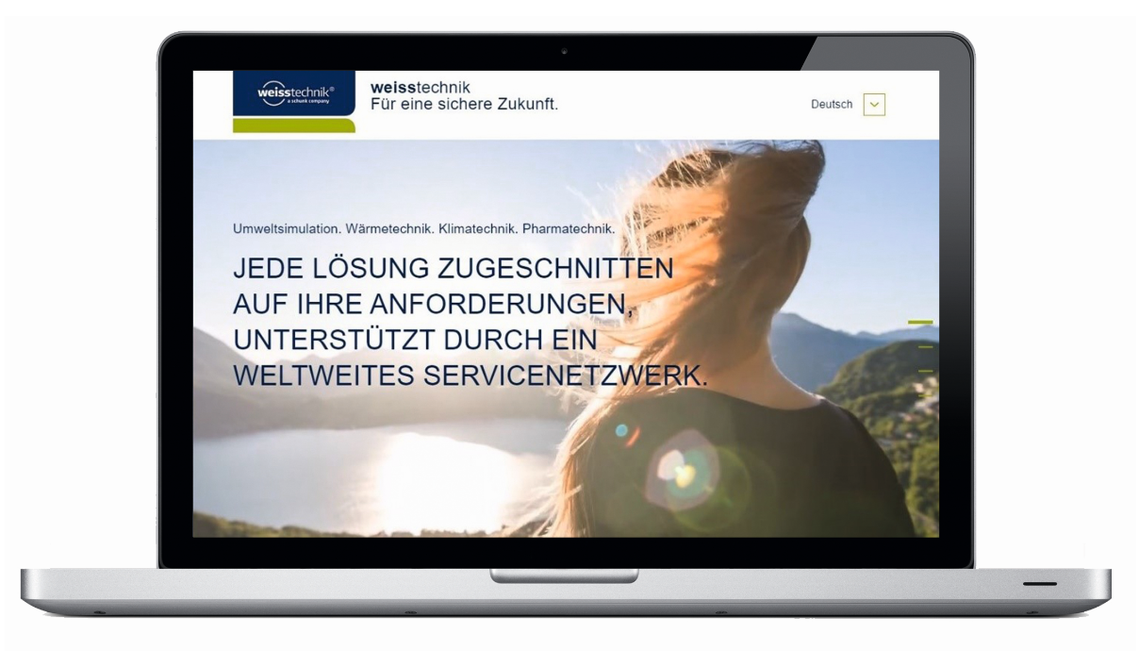
Image 1: A specially created online presence uses numerous examples to show how weisstechnik and its solutions make the world safer (www.weiss-technik.com/en/for-a-safe-future)

The Weiss Technik Companies
Under the slogan “Test it. Heat it. Cool it.”, the Weiss Technik Companies offer solutions that are used around the world in research and development as well as in the production and quality assurance of numerous products. A strong distribution and service organisation with 22 companies at 40 locations in 15 countries ensures optimum customer support and guarantees a high degree of operational safety. The brand weisstechnik® includes individual solutions for environmental simulation, clean rooms, climatic engineering, air dehumidification and containment solutions.
With its test systems from the field of environmental simulation, different environmental influences around the globe can be simulated in time-lapse mode. The product is tested under real load for its functionality, quality, reliability, material resistance and service life. The dimensions of the test equipment range from laboratory test cabinets to test chambers for aircraft components with a volume of several hundred cubic metres. The Weiss Technik Companies are part of the Schunk Group based in Heuchelheim near Gießen, Germany.

Schunk Group
The Schunk Group is a globally operating technology company with a global business unit structure. The company is a leading supplier of products made of high-tech materials – such as carbon, technical ceramics and sintered metal – and machines and systems – from environmental simulation and air conditioning to ultrasonic welding and optical machines. The Schunk Group has more than 9.100 employees in 29 countries and achieved sales of €1.35 billion in 2019.

