Press release
Reiskirchen, 03.01.2020

Contact details
Marco Michels
Press Officer
Tel +49 641 58174-27
marco.michels.external@weiss-technik.com

Claudia Lorch
Marketing Manager Markets
Tel +49 6408 84-6760
claudia.lorch@weiss-technik.com

Weiss Klimatechnik GmbH
Greizer Straße 41-49
35447 Reiskirchen
Germany
www.weiss-technik.com

Hygienic room climate protects against infection –
Vindur® Top hygienic air-cooling unit with thermal disinfection

Waves of infection such as the current outbreak of the coronavirus are a worry for many people. At the same time, they sharpen awareness of hygienic room climate issues, and increase interest in ventilation and air-conditioning systems in public buildings and holidays. If planned poorly or not serviced properly, an air conditioning system can quickly turn into a transmitter of disease-causing germs. With Vindur Top®, Weiss Technik has developed an innovative hygienic air-cooling unit which prevents the growth of bacteria and mould thanks to thermal disinfection, and thus ensures a hygienic room climate.

Improving hygiene with hygienic air-cooling units
Hygienic air-cooling units are recirculating air systems which are often used as supplementary or retrofit solutions if the primary building climate equipment is not dimensioned sufficiently for all rooms or if additional cooling is required. As air cools, condensate can form, providing a breeding ground for bacteria and mould. These develop in particular while the unit is not running, and can be distributed to all rooms when the equipment is put back into operation. To prevent this, Vindur® Top is equipped with a two-level filter (intake side PM1/≥ 50%, pressure side PM1/≥ 80%).

Thermal disinfection kills micro-organisms
To improve hygiene further, Vindur® Top units can be equipped with optional thermal disinfection. This newly developed method effectively prevents the growth of micro-organisms such as bacteria and mould in the air-conditioning unit. Here, the heat exchanger and condensate drip tray are heated and dried completely in turn, controlled by a humidity sensor, so that all micro-organisms are safely destroyed.

Simple handling, two model variants
Vindur® Top hygienic air-cooling units can either be mounted under the ceiling or, equipped with intake and pressure side channel connections, integrated in a suspended ceiling. They have an energy-efficient EC ventilator and a cooler with condensate lifting pump. Air quantity and temperature can be controlled easily and comfortably via the DDC control with web visualisation using the room control panel or touch display. In addition, their smooth surfaces make them easy to clean and disinfect. All the relevant unit parts can be accessed easily through the downward-opening housing flap. This guarantees the straightforward replacement of spare parts.

Meets the very latest German hygiene requirements
The German industry standards body (DIN) and the Association of German Engineers (VDI) recently re-defined the hygiene requirement for ventilation and air conditioning equipment for rooms occupied by persons in DIN 1946-4 and VDI 6022 respectively. In DIN 1946-4, the term rooms occupied by persons, room class II, is used for patients’ rooms, examination and recovery rooms as well as control rooms for CT and MRT scans. However, workstations in office and industrial buildings, sports facilities and break rooms as well as sales and event rooms are also subject to the requirements of VDI 6022. With Vindur® Top, the air conditioning specialist Weiss Technik MediClean® is the first company in the world to offer a hygienic air-cooling unit that reliably meets the new requirements.

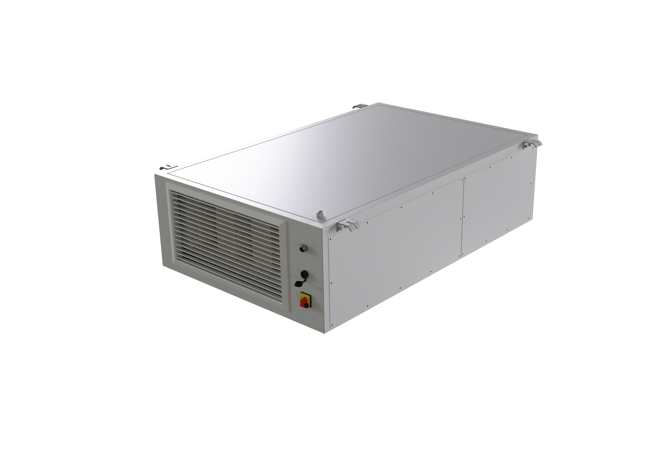
Fig. 1: Vindur® Top with thermal disinfection fulfils the highest hygiene requirements for rooms occupied by persons.

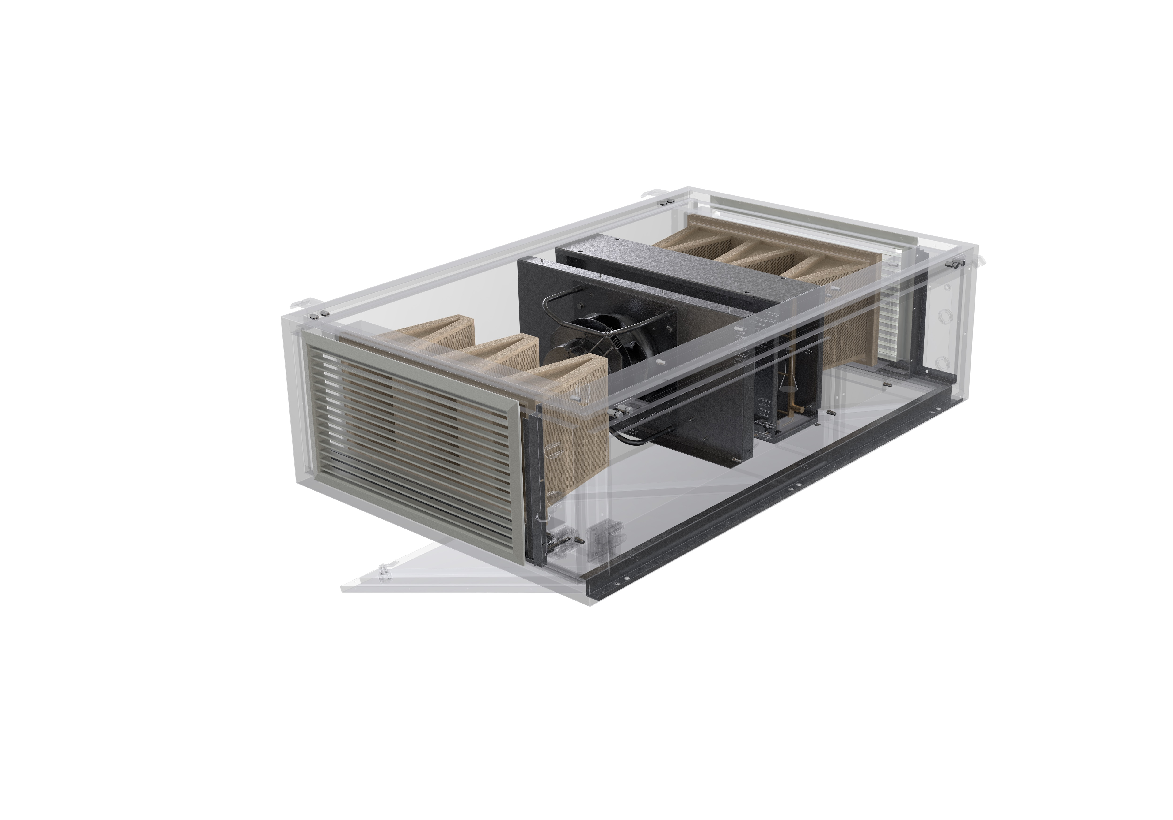 Fig. 2: The innovative hygienic air-cooling unit is equipped with two filter levels and is eadyi to clean and service.
The Weiss Technik companies
With the slogan “Test it. Heat it. Cool it.”, the Weiss Technik companies offer solutions that can be used across the globe in the fields of research and development, as well in the production and quality assurance processes for numerous products. With 22 companies at 40 locations in 15 countries, our experts guarantee optimum support and high operational reliability for your systems. The products included in the weisstechnik® brand include products for environment simulation, thermal and air conditioning technology as well as containment solutions.
Weiss Klimatechnik offers reliable climate solutions where optimum climate solutions are required for people and machinery: in industrial production processes, clean and measuring rooms, hospitals, mobile operating tents or in the field of IT and telecommunications technology. As one of the leading providers of professional clean room and climate solutions, we deliver effective and energy-saving solutions. Our experts will guide you from the planning to the implementation of your projects. The Weiss Technik companies are part of the Schunk Group, which is based in Heuchelheim near Gießen/Germany. www.weiss-technik.com
Schunk Group
The Schunk Group is an international engineering group with around 8,1000 employees
in 29 countries. The company supplies a wide range of products and services from the fields of carbon technology and ceramics, environment simulation and air conditioning technology, sinter metals and ultrasonic welding. The Schunk Group returned sales figures of more than 1.1 billion euros in 2016.
(4,704 characters with spaces)
Can be reproduced free of charge. Please quote Weiss Technik as the source.

