Press release
Reiskirchen, 17.11.2020

Contact details

Weiss Umwelttechnik GmbH
Anika Adams
Phone +49 6408 84-6842
anika.adams@weiss-technik.com
Greizer Straße 41-49
35447 Reiskirchen
Germany
www.weiss-technik.com

Editor
txtconcept Marco Michels
Phone +49 641 58174-27
m.michels@txtconcept.de
www.txtconcept.de

Secure corona vaccine logistics
With pharmaceutical experience and refrigeration technology weisstechnik can support the logistics for corona vaccines

The development of corona vaccines is progressing at a rapid pace and now the safe distribution of vaccine doses must be realised. The new BionNTech vaccine must be transported and stored at
-70 °C and therefore requires an uninterrupted cold chain. As a long-standing partner of the pharmaceutical industry and specialist for extreme temperatures, weisstechnik can offer suitable storage solutions for this.

Generating and maintaining deep freeze safely
The weisstechnik companies are the market leader for environmental simulation and have many years of experience with extreme temperatures. The test cabinets and chambers generate and maintain temperatures of -70 °C extremely evenly and reliably. They work energy-efficiently and with the specially developed environmentally friendly refrigerant WT69.

Large containers and compact cabinets
Vaccine logistics require different cooling capacities at different stages of the supply chain. Many of the offered climatic and temperature test cabinets quickly and safely reach -70°C. This makes them suitable for the temporary storage of smaller vaccine quantities in vaccination centres, hospitals or doctors' surgeries and for short-term capacity bottlenecks. Large batches at airports and distribution centres require walk-in or drive-in temperature chambers. Here weisstechnik offers containers that are quickly ready for operation, including lock systems to prevent icing, fail-safe refrigeration circuits and access controls.

Consistent documentation
In order to document the tamper-proof compliance with the cold chain, weisstechnik uses its proven software S!MPATI® Pharma. This software records, documents, visualises and manages all relevant process data and fulfils all necessary requirements in accordance with EU GMP Annex 11 and FDA 21 CFR Part 11.

Experienced pharma specialist
For many years the weisstechnik companies have been developing solutions that are specially tailored to the requirements of the pharmaceutical and chemical industries, medical technology and laboratories. Therefore, they are very aware of the high quality and safety standards and are able to reliably comply with all relevant standards and specifications.

2,350 characters (including spaces)

More information visit:
www.weiss-technik.com/en/for-a-safe-future?secure-corona-vaccine-logistics

Reprint free of charge. Please state Weiss Technik companies as a source.

Photo material:
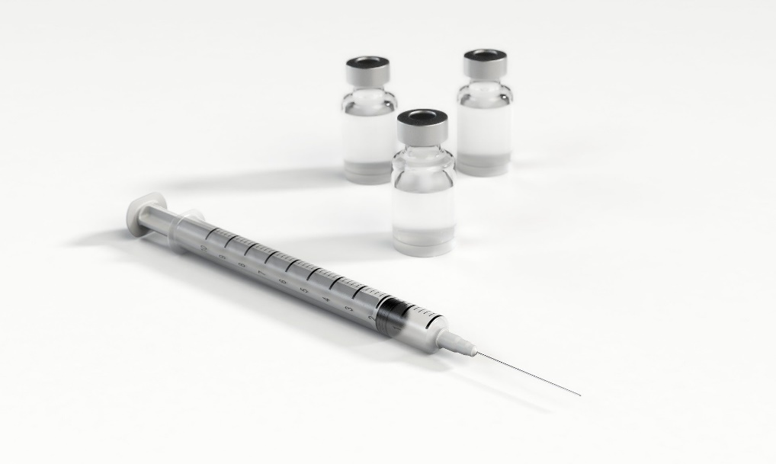
Picture 1: Weiss Umwelttechnik
With pharmaceutical experience and innovative refrigeration technology weisstechnik can support the safe logistics for corona vaccines.
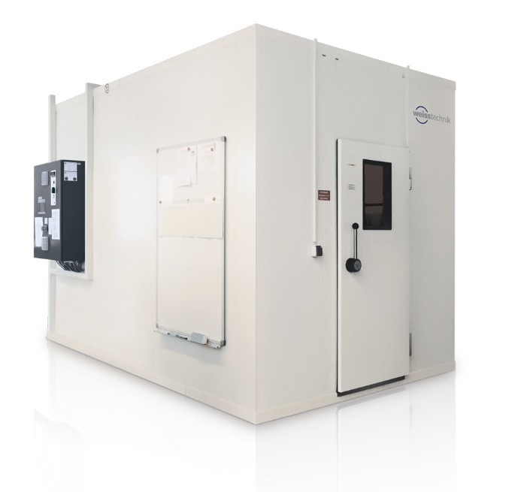
Picture 2: Weiss Umwelttechnik
Many of the climate and temperature test chambers offered by weisstechnik reach -70 °C quickly and safely. This makes them suitable for the temporary storage of smaller vaccine quantities.
The Weiss Technik companies
With the slogan “Test it. Heat it. Cool it.”, the Weiss Technik companies offer solutions that can be used across the globe in the fields of research and development, as well in the production and quality assurance processes for numerous products. A strong sales and service organisation with 22 companies in 15 countries at 40 locations offers excellent support to customers and a high level of operating reliability for the systems. The weisstechnik® brand includes customised solutions for environmental simulations, clean rooms, air conditioning, air dehumidifying and containment solutions. With the test systems from the environmental simulation sector, environmental influences across the globe can be simulated in time lapse. The product to be tested is investigated under real loads in terms of its functionality, quality, reliability, material resistance and lifespan. The dimensions of the test equipment range from laboratory test chambers to test chambers for aeroplane components with a volume of several hundred cubic metres. The Weiss Technik companies are part of the Schunk Group, which is based in Heuchelheim near Gießen/Germany.

Schunk Group
The Schunk Group is a global technology group. The company is a leading provider of products made from high-tech materials – such as carbon, technical ceramics and sintered metal – as well as machines and plants – from environmental simulation to air-conditioning technology and ultrasonic welding to optical machines. The Schunk Group has over 9,100 employees across 29 countries and generated a turnover of 1.35 billion euros in 2019.

