Press Release
Reiskirchen, 11.08.2020

Contact details
yes or no Media GmbH
Claudia Wörner
Vor dem Lauch 4
D-70567 Stuttgart
Phone +49 711 75 85 89 00
claudia.woerner@yes-or-no.de
www.yesorno.de

Editorial staff
txtconcept Marco Michels
Tel +49 641 58174-27
m.michels@txtconcept.de
www.txtconcept.de

Weiss Klimatechnik GmbH
Anika Adams
Tel +49 6408 84-6231
anika.adams@weiss-technik.com
Greizer Straße 41-49
35447 Reiskirchen
Germany
www.weiss-technik.com
Better corona protection and air hygiene for the food industry
The 4+1 safety concept protects people and products

As the coronavirus pandemic has demonstrated, protection from infection is one of the most important challenges to the food industry alongside food safety. This is particularly applicable for the processing of meat, fish and dairy products. weisstechnik hygienic air-conditioning solutions with their 4+1 safety concept provide reliable protection from viruses, mould and bacteria. The optional VOC module provides additional protection from unpleasant odours and their consequences.

Secure air hygiene reliably
Viruses, bacteria and spores are almost everywhere. They spread particularly well in closed rooms where many people are present and food is processed. Examples of these include slaughterhouses, fish processing plants and dairies. weisstechnik hygienic air-conditioning solutions with multi-level safety concept have been designed for use in rooms occupied by persons in the medical field and fulfil the highest safety standards. This makes them ideal for use in the food processing industry too. They reliably protect employees and products from hazards caused by airborne micro-organisms.

Adapt safety flexibly
The hygienic air-conditioning solutions can be individually adapted. The safety levels can be freely chosen according to hygiene requirements, the system performance is scaled to match the room size. For this reason, the hygienic cooling systems can be used in small break and changing rooms just as well as in production halls and packaging areas. Installation is possible as a recessed, sub-structure or mobile solution. Furthermore, combination with an existing on-site cooling system is possible.

Protection through multi-stage safety concept
At the heart of weisstechnik hygienic air-conditioning solutions is the 4+1 safety concept which is effective against coronavirus among other things. A very fine H14 airborne particle filter filters 99.995 % of all airborne particles out of the air during operation, and UVC radiators reliably kill micro-organisms deposited on the filter. The anti-microbial coating of the inner plates confines micro-organisms to an even greater extent. In recirculating air cooling systems, phases when the system is at a standstill are critical in terms of hygiene: the condensate produced as a result of cooling can develop a biofilm which in turn provides an ideal breeding ground for viruses, bacteria and mould. With hygienic air-conditioning systems, this is prevented by the fourth safety stage - innovative thermal disinfection.

Innovative thermal disinfection
Thermal disinfection heats all the relevant installed parts in sequence over 10 minutes to approx. 70 °C, thus drying out the biofilm and reliably making micro-organisms harmless. The recirculating cooling devices are suitable for mobile monitoring or automatic monitoring via the central building management system. This monitoring not only includes the advance indication of maintenance work such as filter replacement, but also displays fault message in order to offer the greatest possible safety while keeping personnel deployment to a minimum.

Additional protection from volatile compounds – VOC
Volatile organic compounds (VOC) are another important problem for the food industry. They not only lead to unpleasant odours but also have a lasting influence on product quality and product safety. For this reason, there is also an air purifier module available as an additional option for the hygienic air-conditioning solutions. This filters unpleasant odours out of the air and decomposes them into harmless carbon and water. As an efficient and economic alternative to activated carbon filters, the air purifier module also provides further protection from coronavirus.

Fulfil hygiene directives in production and break rooms
weisstechnik hygienic air-conditioning solutions with 4+1 safety concept are suitable for versatile use in production, packaging as well as in break and recreation rooms and ensure suitable and hygienic room cooling. They fulfil the strict hygiene directives of VDI 6022 for ventilation and air-conditioning equipment for rooms occupied by persons. Thanks to a cleverly conceived design, they allow any service and maintenance work due to be performed quickly and easily. The innovative web visualisation also makes it possible to open, monitor and control all installed parts and operating states.

4,258 characters (including spaces)

For more information visit www.weiss-technik.com
Reprint free of charge. Please state Weiss Klimatechnik GmbH as the source.

Photo material:
Picture 1: Weiss Klimatechnik GmbH, own image
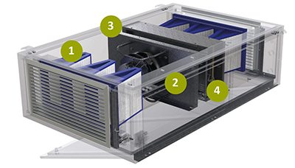
The 4+1 safety concept:
1 Anti-microbial coating of the inner plates; 2 H14 particle filter for 99.995 % less viruses and bacteria in the air; 3 UVC radiators for additional disinfection; 4 Thermal disinfection for hygiene even when the equipment is at a standstill; 4+1 Air purifier to combat VOCs with unpleasant odours

Picture 2: Weiss Klimatechnik GmbH, own image
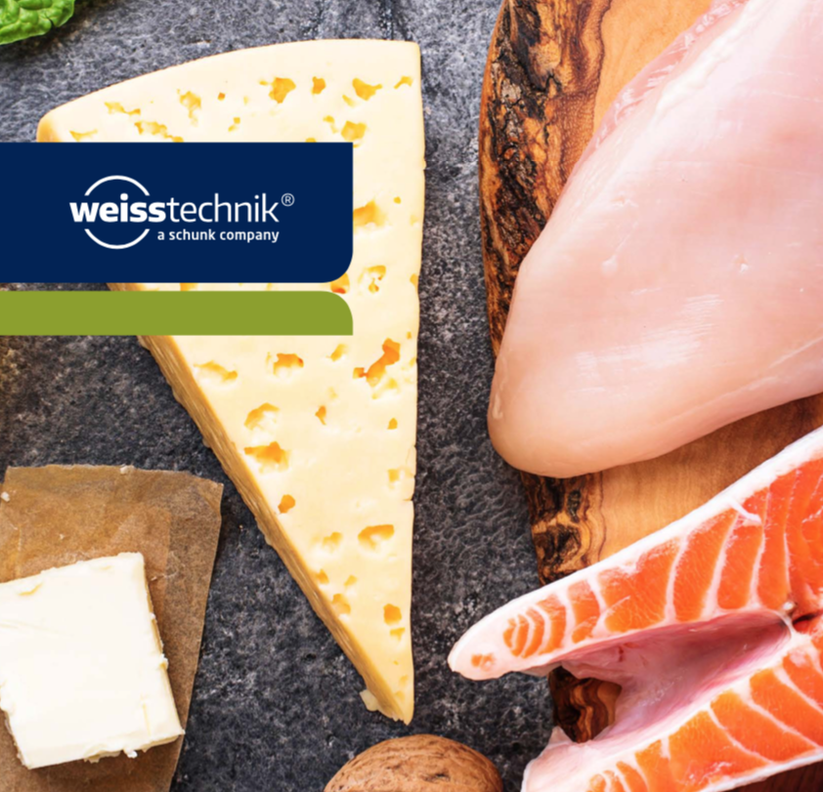
Better corona protection and air hygiene for the food industry.

The Weiss Technik companies
With the slogan “Test it. Heat it. Cool it.”, the Weiss Technik companies offer solutions that can be used across the globe in the fields of research and development, as well in the production and quality assurance processes for numerous products. A strong sales and service organisation with 22 companies in 15 countries at 40 locations offers excellent support to customers and a high level of operating reliability for the systems. The weisstechnik® brand includes customised solutions for environmental simulations, clean rooms, air conditioning, air dehumidifying and containment solutions.
Weiss Klimatechnik offers reliable climate solutions where optimum climate solutions are required for people and machinery: in industrial production processes, clean and measuring rooms, hospitals, mobile operating tents or in the field of IT and telecommunications technology. As one of the leading providers of professional clean room and climate solutions, we deliver effective and energy-saving solutions. Our experts will guide you from the planning to the implementation of your projects. The Weiss Technik companies are part of the Schunk Group, which is based in Heuchelheim near Gießen/Germany.

Schunk Group
The Schunk Group is a global technology group. The company is a leading provider of products made from high-tech materials – such as carbon, technical ceramics and sintered metal – as well as machines and plants – from environmental simulation to air-conditioning technology and ultrasonic welding to optical machines. The Schunk Group has over 9,100 employees across 29 countries and generated a turnover of 1.35 billion euros in 2019.

