Press release
Reiskirchen, 30.03.2020

Contact details
yes or no Media GmbH
Claudia Wörner
Vor dem Lauch 4
70567 Stuttgart
Phone +49 711 75858900
claudia.woerner@yes-or-no.de
www.yesorno.de

Gerlinde Schowalter
Head of Brand Identity and PR
Tel +49 6408 84-6231
gerlinde.schowalter@weiss-technik.com

Weiss Umwelttechnik GmbH
Greizer Straße 41-49
35447 Reiskirchen
Deutschland
www.weiss-technik.com

S!MPATI® 4.70
Easier evaluation and illustration of measured data

With S!MPATI® 4.70 Weiss Umwelttechnik is publishing updated software for the control of environment simulation systems. The system sets benchmarks for the operation, performance and evaluation of measured data.

weisstechnik S!MPATI® is software for the connection and control of environment simulation systems. With the latest release, Weiss Umwelttechnik has extended and improved option and the functions for evaluation of measured data. Among other things, this means:
- faster operation with fewer clicks
- more design options and permanent saving of views
- improved performance for very large series of measurements
- insertion of series of images with only a few mouse clicks.

Efficient interface for fast operation
Processes such as the selection of environment simulations for the required tests and the evaluation of series of measurements are now carried out using a more efficient interface. This becomes clear, for example, when working with the measurement diagrams: in S!MPATI® 4.70 zooming and measurement is done by clicking the diagram rather than opening menu items. This helps users achieve the required representation faster.

There are no hidden functions that users would have to open via the menu structure. In addition, the evaluation of large data sets can now begin immediately, even with lower computer capacity. This is possible because S!MPATI® 4.70 makes the first data

available while the rest of the file is gradually being loaded. This enables evaluation to be started immediately.

Extensive report configuration
S!MPATI® 4.70 allows the presentation of the test results to be influenced in a range of different ways. Users can have the different graphs displayed, adapt scales and define colours. Up to eight such views can be saved. When opened again, they are shown precisely as they were when saved, even including the zoom setting.

Another advantage is the individual integration of measured data evaluation in a laboratory’s own workflow. The user can create and store screenshots easily. These images of graphs or measurements are then available for reports, for example. In addition, the user can export the various parameters to CSV file formats. This makes the evaluation of these data in other systems possible.

More capacity for large data quantities
The weisstechnik S!MPATI® 4.70 software offers stable performance for the evaluation of extended series of measurements. The control software for environment simulation systems even copes with tests covering several million data points. This allows long-term tests to be processed easily as well,

because S!MPATI® 4.70 guarantees consistent capacity for the evaluation of large data quantities in the new release. During long-term tests, for example, many measured values are collected over 1,000 hours. This capacity has been proved by Weiss Umwelttechnik during meticulous test with up to 10 million data points. Depending on the hardware equipment, the software can process even larger data quantities.

Reading in images synchronously to data

The “time labs” additional module has also been upgraded. With this, users integrate camera images easily into the series of measurements. These images make it easier to understand the testing process. During many tests with weisstechnik environment simulation systems the test specimen changes – through corrosion, functional problems or deformation, for example. Such changes can be recorded ideally using series of photos. Weiss Umwelttechnik supplies time labs for the production of such series of photos and their integration in the measured data. This module extends the S!MPATI® software by functions for processing the series of images.

For the creation of the series of images, users define the recording rate, just like with other sensors. The photos are integrated even more easily thanks to tighter integration of time labs in S!MPATI®. It suffices to drag a line across the graphs in the standard editor of S!MPATI® 4.70- The editor displays each photo recorded by time labs synchronously in time with the series of measurements. The photos can also be saved and edited. These improvements are a significant upgrade for the evaluation functions of the software.

4,285 characters (including spaces)

For more information visit www.weiss-technik.com
Reprint free of charge. Please state Weiss Umwelttechnik GmbH as the source.

Photo material:
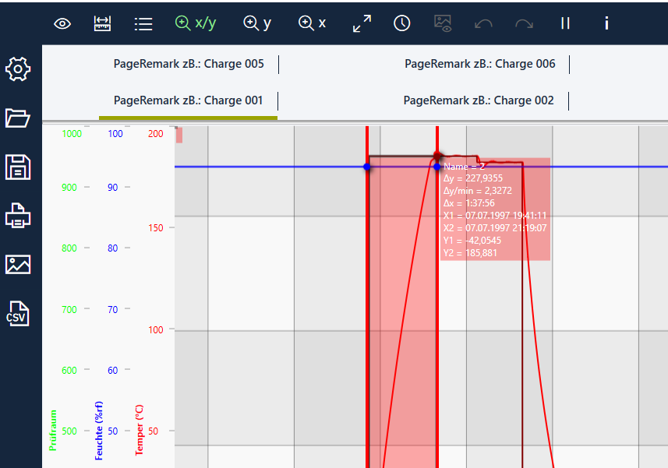
Photo 1: weisstechnik, own image
Processes such as the selection of environment simulations for the required tests and the evaluation of series of measurements are now carried out using an improved, more efficient interface in S!MPATI® 4.70.

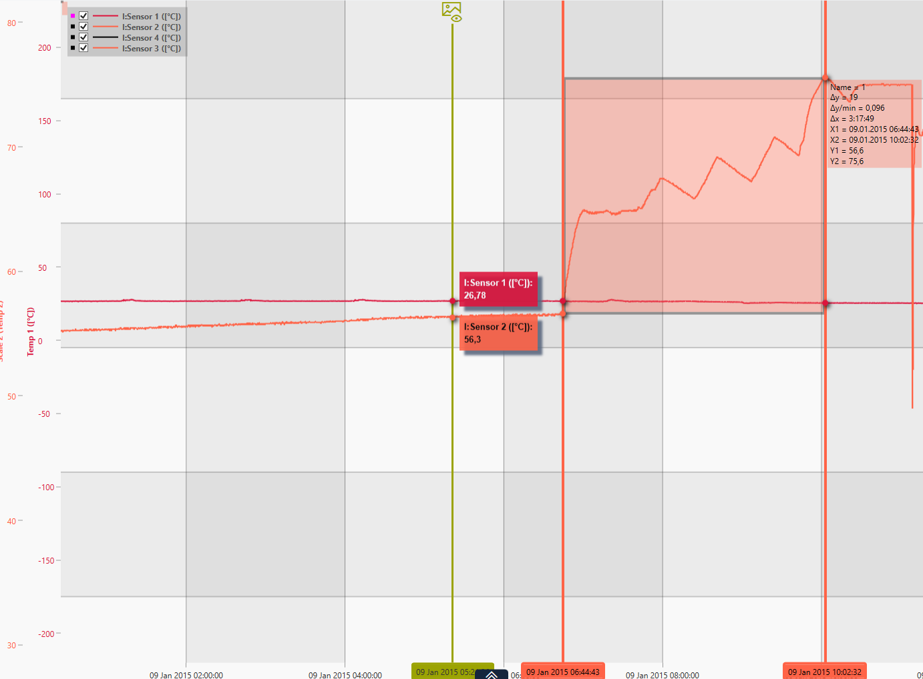
Photo 2: weisstechnik, own image
With S!MPATI® 4.70 the views are shown precisely in the same way they were stored the next time they are opened - even including the same zoom setting.

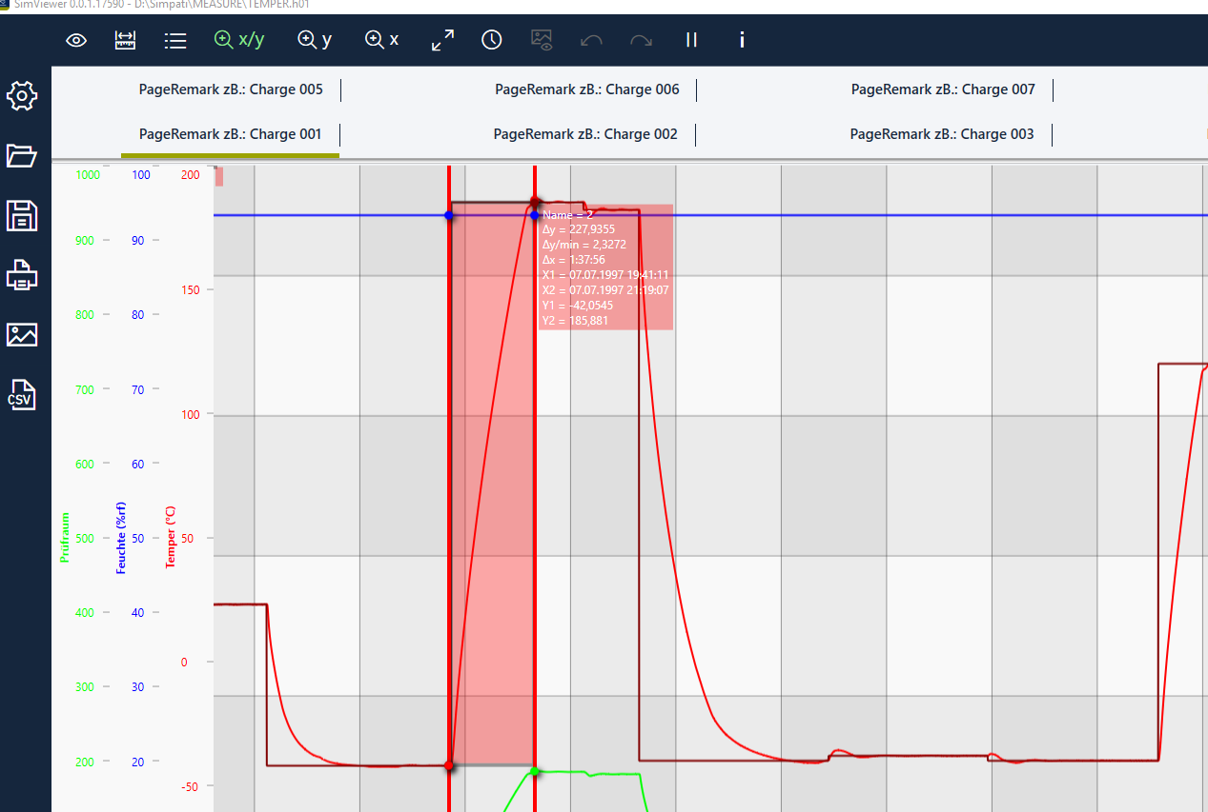

Photo 3: weisstechnik, own image
In the new release, weisstechnik S!MPATI® 4.70 guarantees consistent capacity for the evaluation of large data quantities.

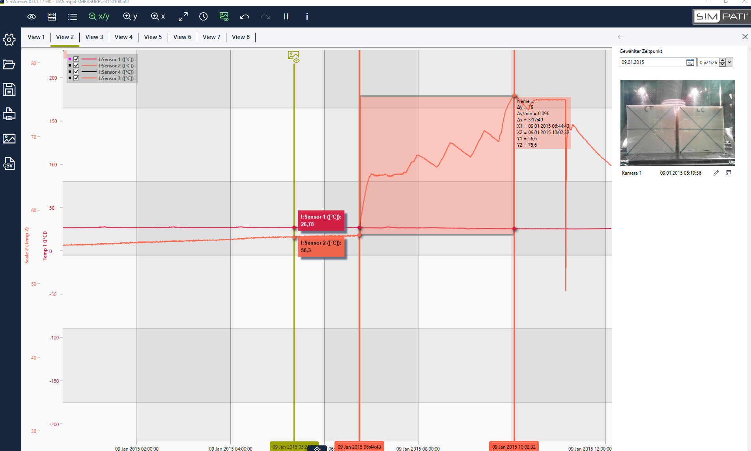
Photo 4: weisstechnik, own image
The standard editor of S!MPATI® 4.70 displays each of the images recorded by time labs at the time synchronous to the series of measurements.

The Weiss Technik Companies
Under the slogan “Test it. Heat it. Cool it.”, the Weiss Technik Companies offer solutions that are used around the world in research and development as well as in the production and quality assurance of numerous products. A strong distribution and service organisation with 22 companies at 40 locations in 15 countries ensures optimum customer support and guarantees a high degree of operational safety. The brand weisstechnik® includes individual solutions for environmental simulation, clean rooms, climatic engineering, air dehumidification and containment solutions. With its test systems from the field of environmental simulation, different environmental influences around the globe can be simulated in time-lapse mode. The product is tested under real load for its functionality, quality, reliability, material resistance and service life. The dimensions of the test equipment range from laboratory test cabinets to test chambers for aircraft components with a volume of several hundred cubic metres. The Weiss Technik Companies are part of the Schunk Group based in Heuchelheim near Gießen, Germany.

Schunk Group
The Schunk Group is a globally operating technology company with a global business unit structure. The company is a leading supplier of products made of high-tech materials – such as carbon, technical ceramics and sintered metal – and machines and systems – from environmental simulation and air conditioning to ultrasonic welding and optical machines. The Schunk Group has more than 8500 employees in 29 countries and achieved sales of €1.28 billion in 2018.

