TECHNICAL ARTICLE
Reiskirchen, 01.06.2020

Contact details
yes or no Media GmbH
Claudia Wörner
Vor dem Lauch 4
D-70567 Stuttgart
Phone +49 711 75 85 89 00
claudia.woerner@yes-or-no.de
www.yesorno.de

Gerlinde Schowalter
Head of Brand Identity and PR
Tel +49 6408 84-6231
gerlinde.schowalter@weiss-technik.com

Weiss Umwelttechnik GmbH
Greizer Straße 41-49
35447 Reiskirchen
Deutschland
www.weiss-technik.com

S!MPATI® online
Test systems go online

S!MPATI® online from Weiss Umwelttechnik makes intra-site management of all test systems possible. Test reports are also issued via the internet – semi-automatically and with maximum security.

S!MPATI® online is expanding S!MPATI® 4.70 from weisstechnik by cloud-based functions. Important aspects of the software for the management of environment simulation systems can thus be executed via the internet. These include:

• Semi-automated reporting
• Monitoring of systems and test specimens
• Management of climatic tests
• Guaranteeing data security

Faster preparation of reports
Laboratories often have to prepare test reports exactly standard-compliant. This usually means a lot of work, especially for laboratories without their own programmed and usually expensive laboratory management systems. S!MPATI® online now carries out this task semi-automatically, including results protocol and graphs. The data are exported as a Word file, allowing users to make final adjustments.

Since S!MPATI® online is cloud-based, the test reports are prepared independently of the site. The only pre-requisite is that S!MPATI® 4.70 software is installed on site. An internet gateway developed by weisstechnik loads the measured data to the cloud. S!MPATI® online then processes these data and makes them available to the user via a web browser and in Word format.

Overview of plant states and protocols
The monitoring of tests and test specimens also involves a lot of organisation for laboratories. S!MPATI® online saves a considerable amount of time and work here, too. The test specimen is always at the heart of the planning. The software delivers all the plant information from the different sites constantly to the cloud. The laboratory employee then determines which test the object is to undergo when on which system.

Once all tests have been completed, a test protocol can be prepared semi-automatically. The current status of the tests can be inquired in the system at all times. In addition, device states of the environment simulation plants for the entire laboratory can be queried. This means utilisation and test-related result protocols can be viewed.

Joint planning of tests for all sites
The organisation of climatic tests is now carried out independently of the site with the cloud-based software. This is a big advantage for laboratories with several sites or personnel that is often off-site. Laboratory employees and other authorised users can open the planning status and test results via the browser. Additional advantage: evaluations are not time-restricted and are stored securely. This means the user can easily access old data and evaluations for recurring tests as well as apply current evaluations to old measuring data.

Maximum security is provided for all online functions. Thus the data are saved on Microsoft Azure servers in the EU in compliance with European data protection regulations, for example. Security is a constituent part of the S!MPATI® online concept, since the software only reads the data provided by local installations. This prevents malware and undesired operating states being implanted. S!MPATI® online is also protected against failure of the internet connection. In the event of a problem, the data are saved for an unlimited period of time in a temporary file until the internet connection has been restored. In addition, the data are saved redundantly in the cloud and are protected against physical problems such as fire or water damage.

All these measures mean that S!MPATI® online achieves a higher level of data security coupled with maximum convenience.

3,699 characters (including spaces)

For more information visit www.weiss-technik.com
Reprint free of charge. Please state Weiss Umwelttechnik GmbH as the source.

Photo material:
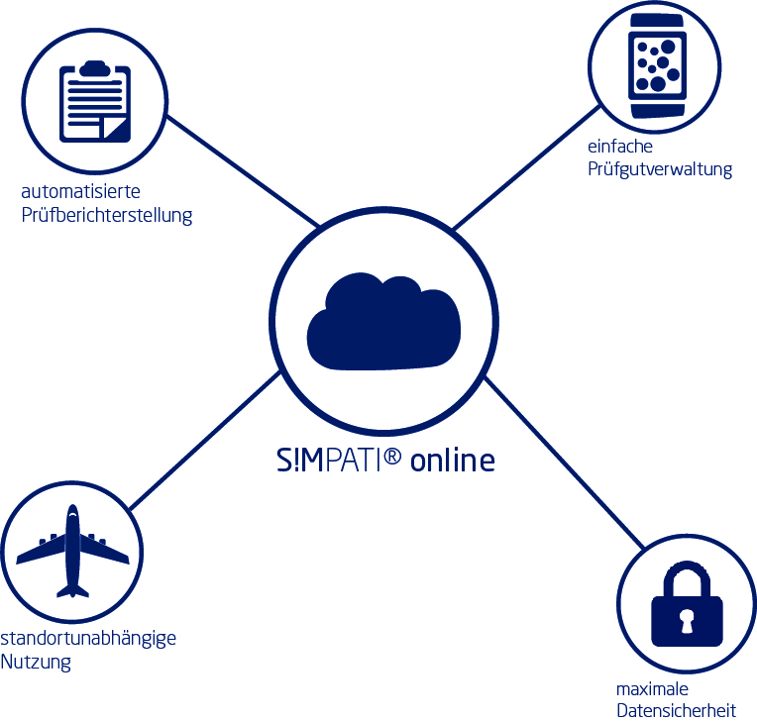
Picture 1: Weiss Umwelttechnik GmbH, own image
S!MPATI® online is expanding S!MPATI® 4.70 from weisstechnik by cloud-based functions. Important aspects of the software for the management of environment simulation systems can thus be executed via the internet.

The Weiss Technik companies
With the slogan “Test it. Heat it. Cool it.”, the Weiss Technik companies offer solutions that can be used across the globe in the fields of research and development, as well in the production and quality assurance processes for numerous products. A strong sales and service organisation with 22 companies in 15 countries at 40 locations offers excellent support to customers and a high level of operating reliability for the systems. The weisstechnik® brand includes customised solutions for environmental simulations, clean rooms, air conditioning, air dehumidifying and containment solutions. With the test systems from the environmental simulation sector, environmental influences across the globe can be simulated in time lapse. The product to be tested is investigated under real loads in terms of its functionality, quality, reliability, material resistance and lifespan. The dimensions of the test equipment range from laboratory test chambers to test chambers for aeroplane components with a volume of several hundred cubic metres. The Weiss Technik companies are part of the Schunk Group, which is based in Heuchelheim near Gießen/Germany
Schunk Group
The Schunk Group is a global engineering group with more than 8,500 employees in 29 countries. The company supplies a wide range of products and services from the fields of carbon technology and ceramics, environment simulation and air conditioning technology, sinter metals and ultrasonic welding. The Schunk Group returned sales figures of around 1.2 billion euros in 2018.

