Press release

新闻稿
Reiskirchen, 04.02.2020

Contact details
Marco Michels
Press officer
Tel +49 641 58174-27
marco.michels.external@weiss-technik.com

Gerlinde Schowalter
Head of Brand Identity and PR
Tel +49 6408 84-6231
gerlinde.schowalter@weiss-technik.com

Weiss Umwelttechnik GmbH
Greizer Straße 41-49
35447 Reiskirchen
Germany
www.weiss-technik.com

WACKER CHEMIE AG relies on

testing technology and service from weisstechnik
瓦克化学股份有限公司（WACKER CHEMIE AG）信赖伟思技术的测试技术

With more than 14,500 employees around the world, WACKER CHEMIE AG is one of the innovation and technology leaders for specialist chemical products. One important area of work is the development and optimisation of primary products and recipes. Testing under certain climatic conditions is a central step within the development process. For this reason, WACKER relies on tried-and-tested and versatile climate test cabinets and chambers from weisstechnik.
瓦克化学股份有限公司是特种化学产品的创新和技术领导者之一，在全球拥有超过14,500名员工。其业务的一个重要领域是主要产品和配方的开发和优化。在某些气候条件下进行测试是开发过程中的核心步骤。因此，瓦克依赖伟思技术久经考验的多功能气候试验箱。

Stimulating industry for 80 years
促进行业发展80年
With 23 production locations around the world, more than 3,200 products and a turnover of about 5 billion €, WACKER CHEMIE AG is represented in almost all relevant key industries. One important area is the construction industry, for whom WACKER develops tile adhesives, paints and plaster, self-spreading compounds, thermal insulation systems, waterproofing slurries, adhesives and bitumen coating. WACKER works closely with its customers in order to reliably achieve the required product properties and check these in series of tests.
瓦克化学股份有限公司在全球有23个生产基地，拥有超过3,200种产品和约50亿欧元的营业额，几乎在所有相关关键行业中都有代表产品。瓦克为建筑行业开发了重要领域：瓷砖粘合剂、涂料和灰泥、自铺展剂、隔热系统、防水泥浆、粘合剂和沥青涂料。瓦克与客户紧密合作，以可靠地获得所需的产品性能并进行一系列测试。
Central testing equipment for eight laboratory groups
八个实验室小组只用集中测试设备
At company headquarters in Burghausen near Munich, eight laboratory groups access the test laboratory testing technology. Among other things, this comprises a total of six weisstechnik standard climate test chambers and a special test chamber for larger test specimens. In addition, the location has a complete climate laboratory from weisstechnik. Here, applications can be tested under a wide range of realistic climatic conditions. It is possible to test, for example, how a bitumen mass can be processed at + 40 °C and 90% humidity in Dubai, or whether cracks appear in the same mass at - 20 °C in Moscow. This represents an enormous cost advantage, significant time saving and reliable way of achieving reliably comparable test results.
在位于慕尼黑附近伯格豪森的公司总部，八个实验室小组使用了实验室测试技术，其中包括总共六个伟思技术的标准气候试验箱和一个用于大型测试样品的特殊试验箱。此外，该地还有一个来自伟思技术的全气候实验室。在这里，可以在各种实际气候条件下进行测试。例如，可以在迪拜的气候下进行测试，如何在+40℃和90%的湿度下处理沥青块；或者在莫斯科的气候下进行测试，在-20℃的温度下测试同一个沥青块是否出现裂纹。这代表了巨大的成本优势，明显节省时间以及得到可靠的可比对的测试结果。

Testing technology from the inventor of environment simulation
环境模拟创造者的测试技术
WACKER specifically release on testing technology from weisstechnik for the tests. On the one hand because they can precisely achieve the required climatic conditions – generally temperature and humidity. On the other because the devices and chambers work extremely reliably and are ready for use again quickly following maintenance. Michael Killermann, application engineer at WACKER: “We are extremely satisfied with the equipment and the service is perfect. On the rare occasions that intervention is necessary, the technicians always know what to do and get the system up and running again quickly.“ The climate test chambers WK3-180/40 used work with temperatures from - 40 to + 180 °C and a relative humidity of 15 to 98%. This means they cover all standard testing tasks at WACKER, which carries out testing on bitumen mainly in the range between - 20 and + 70 °C. In addition, there is a test chamber for large test specimens available at the site, as well as a frost-dew chamber. Single and multi-stage tests are carried out in the test chambers over periods of between one hour and four weeks and more. One typical test is the startup and holding of various temperatures in succession, for example 0 °C, + 23°C, - 5 °C and - 20 °C.
瓦克专门发布了基于伟思技术的测试技术的测试结果。一方面，是因为它们可以精确地达到所需的气候条件—通常是温度和湿度；另一方面，因为设备和试验箱工作稳定可靠，并且在维护后可以很快再次使用。瓦克应用工程师Michael Killermann说：“我们对设备非常满意，服务也非常完美。在极少数需要干预的情况下，技术人员总是知道该怎么做并使系统快速重新启动和运行。” WK3-180/40型气候试验箱使用的工作温度为-40至+180℃，相对湿度为15至98%，而瓦克主要在-20至+70℃的温度范围内进行沥青测试，这意味着它们涵盖了瓦克所有标准的测试任务。此外，现场还设有一个用于大型样品测试的试验箱以及一个霜冻箱。单阶和多阶测试在试验箱中进行，测试时间为一小时至四星期，甚至更长时间。一种典型的测试是依次启动和保持各种温度，例如0 °C, + 23°C, - 5 °C 和 - 20 °C。

Tests at the inventor of dispersible powder
分散粉发明者的测试
In the bitumen sector, WACKER mainly develops sealing coatings for cellars and roofs to customer orders. For this, the existing bitumen paste is optimised with VINNAPAS® dispersible powder and other additives in such a way that the required resistance in the respective area of application or climatic zone is reliably guaranteed. As the manufacturer of the first dispersible powder in 1957 and market leader in this field, WACKER has a comprehensive range of experience to fall back on. This is important since numerous customer-imposed and building approval-related requirements have to be observed during development. No fewer than 21 different standards must be taken into account for bitumen products for public buildings, for example. As a quality leader, WACKER feels it is especially important to observe the required test values exactly, as Killermann explains: “We always want to offer our customers the perfect solution. For this, we need precise test results of course, which we can reliably achieve using the testing technology from weisstechnik.”
在沥青领域，瓦克主要根据客户需求开发用于酒窖和屋顶的密封涂料。为此，使用VINNAPAS®分散性粉末和其它添加剂对现有的沥青糊进行优化，以确保在相应的应用领域或气候区域可靠地保证所需的抵抗力。作为1957年第一批可分散粉末的制造商和该领域的市场领导者，瓦克拥有丰富的经验。这很重要，因为在开发过程中必须遵守许多客户提出的要求和与建筑物批准有关的要求。例如，用于公共建筑的沥青产品必须考虑不少于21种不同的标准。作为质量领导者，瓦克认为准确观测要求的测试数据尤为重要，正如Killermann所说：“我们始终希望能为客户提供完美的解决方案。为此，我们当然需要精确的测试结果，我们可以使用伟思技术的测试技术可靠地获得这些结果。”

Simple handling, perfect planning
操作简单，规划完善
Precise planning is necessary to exploit the testing technology of the laboratory group in Burghausen in the best way possible. There is an employee responsible, who coordinates all the tests and programs the testing systems in such a way that they are ready for use perfectly conditioned at the required time. Since the application engineers’ workstations are quite some way away from the test laboratory, they can monitor the tests via remote access at their PC or smartphone at any time – even at the weekend. This is extremely convenient, particularly when longer series of tests are performed.
为了以最佳方式利用伯格豪森实验室组的测试技术，必须进行精确的计划。有一个负责的员工，他负责协调所有的测试并对测试系统进行编程，以使其可以在要求的时间具备使用条件。应用工程师的工作站距离测试实验室还有一段距离，但是他们可以随时通过电脑或智能手机上的远程访问来监视测试，甚至可以在周末。这非常方便，特别是进行长时间测试的时候。

Make the world a little better with testing technology
通过测试技术让世界变得更好一点点
The development and optimisation of basic materials, recipes and finished mixtures in climate test chambers offers many advantages. On the one hand, WACKER can test and adapt viscosity and curing behaviour. This makes it possible for the company fulfil the requirements of its customers, who always demand shorter construction times with reduced drying times and work even at low temperatures. On the other hand, the testing technology makes a contribution to environmental protection. “Rather than flying around the world and testing a product in Moscow, Dubai and Hamburg, we produce the climate in the test chambers on our premises. That is faster, more reliable and goes easy on the environment,” concludes a satisfied Mr. Killermann.
在气候试验箱中进行基础材料、配方和成品混合物的开发和优化具有许多优势。一方面，瓦克可以测试并适应粘度和固化性能。这使公司有可能满足其客户的要求，这些客户始终要求缩短施工时间，减少干燥时间，即使在低温下也可以工作。另一方面，测试技术为环境保护做出了贡献。“与在世界各地飞行并在莫斯科、迪拜和汉堡测试产品相比，我们在试验箱里模拟了气候，这样更快、更可靠并且更容易实现。” Killermann先生满意地总结道。

Reprint free of charge. Please state Weiss Technik as the source.
免费转载，但请注明来源自伟思技术。

Picture material: 图片素材：
Copyright: Wacker AG and Weiss Technik, as stated next to the picture
版权：瓦克公司和伟思技术，如图所示。

Picture 1: 图片1:
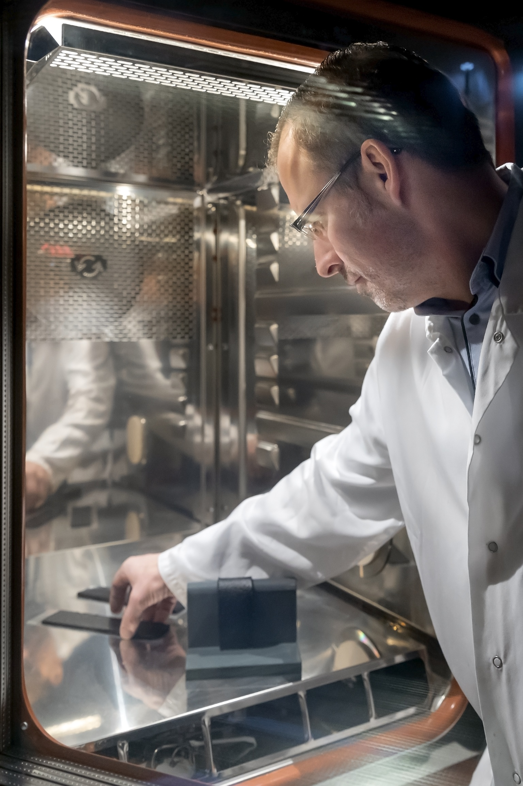

Copyright: Wacker Chemie AG
版权：瓦克化学股份有限公司

Crack bridging tests are carried out to test the properties of bitumen under certain climatic conditions.
在某些气候条件下进行裂缝桥接测试以测试沥青的特性。

Picture 2: 图片2
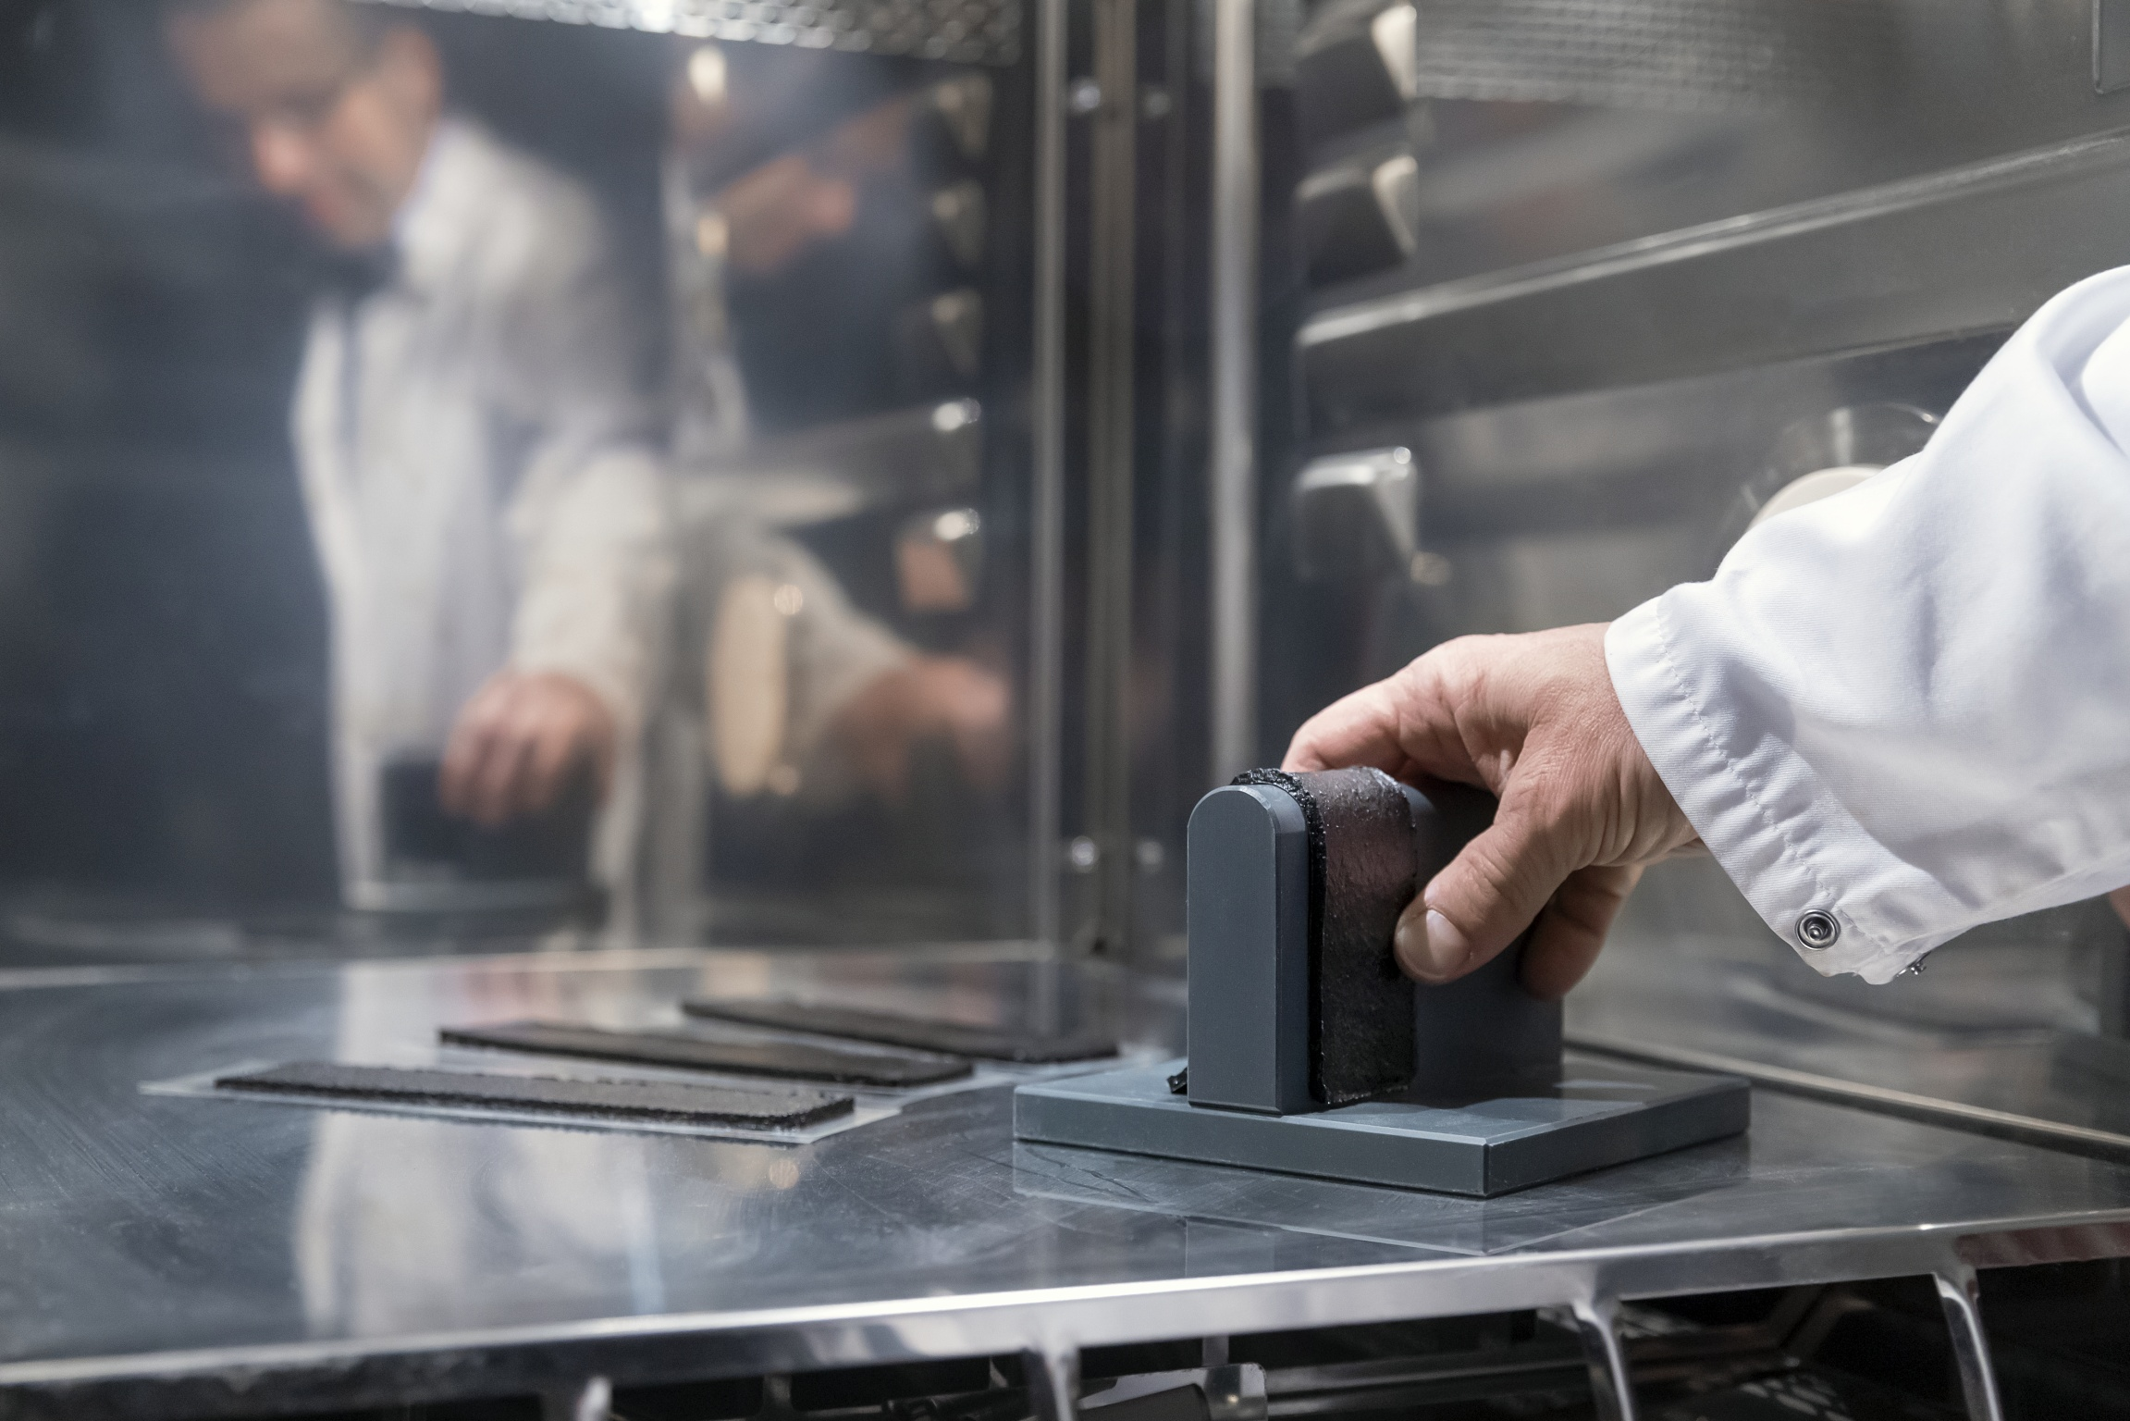
Copyright: Wacker Chemie AG
版权：瓦克化学股份有限公司

The properties of a product can be determined precisely and adapted to customer wishes using one- and multi-stage tests.
产品的性质可以通过单阶和多阶的测试精确地确定并适应客户的需求。

Picture 3: 图片3：
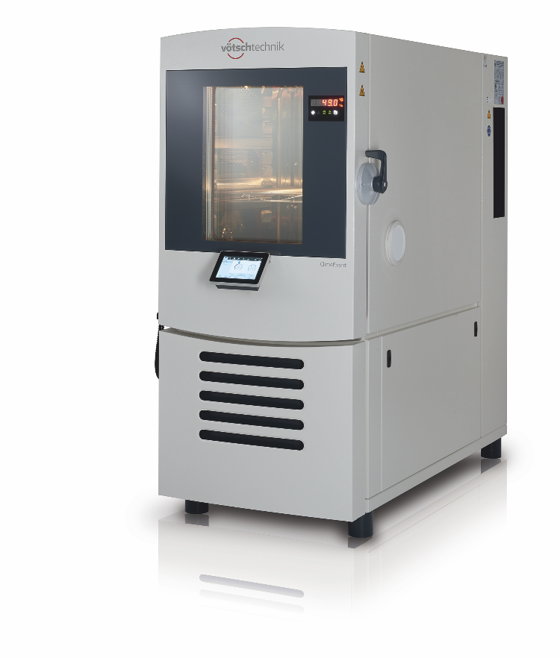
Copyright: Weiss Technik
版权：伟思技术

Unique in the branch: WACKER CHEMIE uses six climate test chambers and one large climatic test chamber in Burghausen. Show here: one current weisstechnik ClimeEvent test chamber.
分支机构中的独特之处：瓦克化学在伯格豪森使用了六个气候试验箱和一个大型气候试验箱。此处展示：最新的伟思技术ClimeEvent系列试验箱

Picture 3: 图片3：
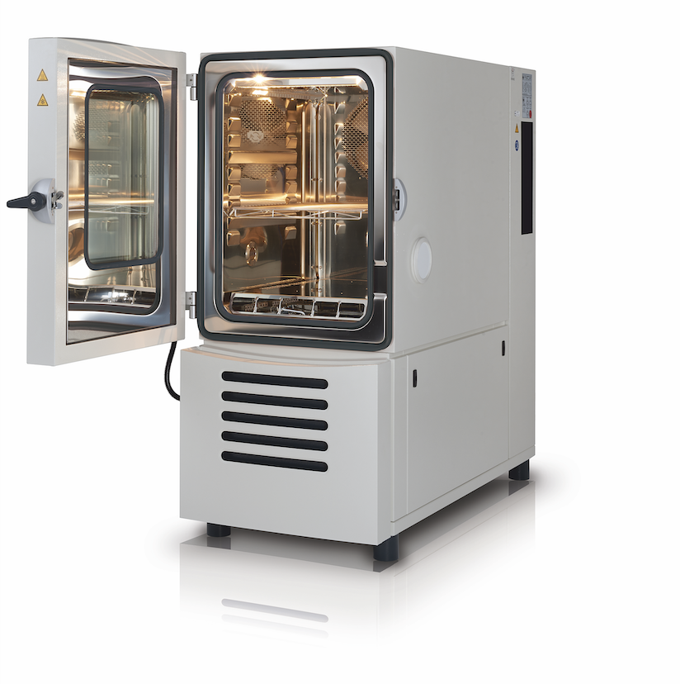
Copyright: Weiss Technik
版权：伟思技术

weiss technik climate test chambers are extremely flexible and cover numerous test scenarios precisely and reliably.
伟思技术气候试验箱非常灵活，可精确可靠地覆盖多种测试场景。
Weiss Technik
伟思技术
With the slogan “Test it. Heat it. Cool it.”, the Weiss Technik companies offer solutions that can be used across the globe in the fields of research and development, as well in the production and quality assurance processes for numerous products. A strong sales and service organisation with 22 companies in 15 countries at 40 locations offers excellent support to customers and a high level of operating reliability for the systems. The weisstechnik® brand includes customised solutions for environmental simulations, clean rooms, air conditioning, air dehumidifying and containment solutions. With the test systems from the environmental simulation sector, environmental influences across the globe can be simulated in time lapse. The product to be tested is investigated under real loads in terms of its functionality, quality, reliability, material resistance and lifespan. The dimensions of the test equipment range from laboratory test chambers to test chambers for aeroplane components with a volume of several hundred cubic metres. The Weiss Technik companies are part of the Schunk Group, which is based in Heuchelheim near Gießen/Germany.
Test it. Heat it. Cool it.
伟思技术针对研发、生产和产品品质保证的解决方案在全世界范围内得到了应用。我们的专业人员来自14个国家的21个公司，时刻准备为您提供支持服务以高度确保系统的可靠运行。weisstechnik®品牌包括针对环境模拟、洁净室、空调、空气除湿和围阻解决方案的定制解决方案。使用来自环境模拟部门的测试系统，可以模拟全球超越时间和地域的各种气候条件。在实际负载下对被测产品进行功能、质量、可靠性、材料耐受性和使用寿命方面的研究。从实验室标箱到数百立方米的飞机部件测试箱，伟思技术可以提供不同尺寸的测试系统。伟思技术隶属于位于德国吉森附近的Schunk（崇德）集团，
Schunk Group
崇德集团
The Schunk Group is a global technology corporation – acting as a medium-sized company but with a global business unit structure. The company is a leading provider of products made from high-tech materials – such as carbon, technical ceramics and sintered metal – as well as machines and plants – from environmental simulation to air-conditioning technology and ultrasonic welding to optical machines. The Schunk Group has over 8,500 employees across 29 countries and generated a turnover of 1.28 billion euros in 2018.
崇德集团是一家全球性的技术企业—中型公司，但具有全球业务部门结构。该集团是由高科技材料（如碳、工业陶瓷和烧结金属）以及机器和工厂（从环境模拟到空调技术以及从超声波焊接到光学机器）制成的产品的领先提供商。崇德集团在全球29个国家和地区拥有8,500多名员工，2018年的营业额为12.8亿欧元。

