Press release
Reiskirchen, 26.05.2020

Contact details
yes or no Media GmbH
Claudia Wörner
Vor dem Lauch 4
D-70567 Stuttgart
Phone +49 711 75 85 89 00
claudia.woerner@yes-or-no.de
www.yesorno.de

Gerlinde Schowalter
Head of Brand Identity and PR
Tel +49 6408 84-6231
gerlinde.schowalter@weiss-technik.com

Weiss Umwelttechnik GmbH
Greizer Straße 41-49
35447 Reiskirchen
Germany
www.weiss-technik.com

German Innovation Award 2020
Award-winning refrigerant from Weiss Umwelttechnik

Weiss Umwelttechnik has received the German Innovation Award 2020 for its R-469A refrigerant. It is an ideal, eco-friendly alternative to the climate-damaging R-23.

“With its revolutionary R-469A refrigerant, Weiss Umwelttechnik has developed a more environmentally friendly substitute for the extremely climate-damaging R-23 refrigerant used up to now. The company is thus making an important contribution to environment and climate protection,” the jury explained. “It is remarkable that Weiss Umwelttechnik is not a chemicals giant but rather a medium-sized company for environment simulation systems. This makes the development performance for such an agent all the more impressive.”

Overall, more than 700 innovations were submitted as entries for the award by companies including industry giants such as SAP, Evonic, L'ORÉAL and Continental. With the German Innovation Award, the Design Council honours pioneering and sustainable innovations.

The special feature of the R-469A refrigerant is that it cools down to -70 °C and still fulfils the requirements made by the EU, since it releases 90 percent less greenhouse gases than alternative refrigerants. R-469A is used in environment simulation systems for product and quality tests among other things. Up to now, refrigeration systems were only able to reach extremely low temperatures of below -40 °C with the aid of the R-23 refrigerant. Yet R-23 has an enormous global warming potential and is thus only permitted within the context of a transition regulation in the EU.

Weiss Umwelttechnik sells the refrigerant with the official designation R-469A under the brand name WT69. The company has already converted half its own portfolio to the new agent. It is available independently of the climate chambers from Weiss Umwelttechnik.

1,820 characters (including spaces)

For more information visit www.weiss-technik.com

Reprint free of charge. Please state Weiss Umwelttechnik GmbH as the source.

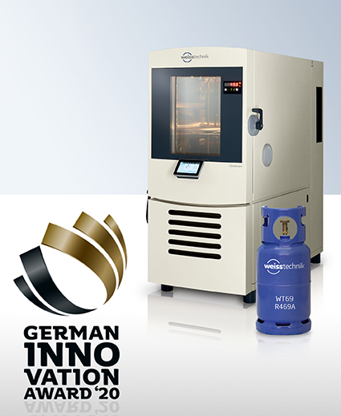
Fig. 1: The R-469A refrigerant developed by Weiss Umwelttechnik for environment simulation systems is one of the winners of the German Innovation Award 2020.

The Weiss Technik Companies
Under the slogan “Test it. Heat it. Cool it.”, the Weiss Technik Companies offer solutions that are used around the world in research and development as well as in the production and quality assurance of numerous products. A strong distribution and service organisation with 22 companies at 40 locations in 15 countries ensures optimum customer support and guarantees a high degree of operational safety. The brand weisstechnik® includes individual solutions for environmental simulation, clean rooms, climatic engineering, air dehumidification and containment solutions.
Weiss Klimatechnik provides reliable air-conditioning solutions wherever optimal climatic conditions for man and machine are required: in industrial production processes, clean rooms and measuring rooms, hospitals, mobile operation tents or in the information and telecommunication technology fields. As one of the leading providers of professional clean room and air-conditioning systems, we provide you with effective and energy saving solutions, and support you with our expertise from the planning to the implementation of your projects. The Weiss Technik companies are part of the Schunk Group, which is based in Heuchelheim, close to Giessen.

Schunk Group
The Schunk Group is a globally operating technology company with a global business unit structure. The company is a leading supplier of products made of high-tech materials – such as carbon, technical ceramics and sintered metal – and machines and systems – from environmental simulation and air conditioning to ultrasonic welding and optical machines. The Schunk Group has more than 9.100 employees in 29 countries and achieved sales of €1.35 billion in 2019.

