Press Release
Reiskirchen, 11.03.2021

Contact details
yes or no Media GmbH
Claudia Wörner
Vor dem Lauch 4
D-70567 Stuttgart
Phone +49 711 75 85 89 00
claudia.woerner@yes-or-no.de
www.yesorno.de

Daphne Palme
MM Communications
Tel +49172 8569 476
daphne.palme@weiss-technik.com

Weiss Technik GmbH
Greizer Straße 41-49
35447 Reiskirchen
Deutschland
www.weiss-technik.com

R469A tested for Danfoss valves
Endurance test passed

weisstechnik tested Danfoss expansion valves for compatibility with the cryogenic refrigerant R469A. The results were so convincing that Danfoss included R469A in its calculation programme for refrigeration systems. At the same time, weisstechnik now has access to an extensively tested class of valves for its systems.

weisstechnik has successfully tested Danfoss AVK electrically controlled expansion valves for use in environmental test chambers. Weiss tested the durability of the valves under sustained load and their resistance during operation with R469A. This is a refrigerant for very low temperatures that Weiss developed as a replacement for R23. This product launch became necessary as R23 no longer complies with the EU regulation on greenhouse gases.

The test results were convincing: on weisstechnik's test benches, the Danfoss valves worked perfectly right up to the end of the test. Even with R469A, they worked without any problems. These results were also so impressive for Danfoss that the manufacturer included R469A in its calculation programme for the design of refrigeration systems.

Danfoss valves successfully tested with R469A
weisstechnik had intensively investigated the AVK expansion valves from Danfoss, as the experts from weisstechnik saw potential for improvement in them for the climate and temperature test chambers. The long service life of 50 million switching cycles stated by Danfoss is particularly interesting. At the same time, these electronic valves enable fast and accurate temperature changes. They are controlled by pulse width modulation, i.e. by a rapid sequence of opening pulses of different lengths. This allows the valve to quickly change the flow rate. Finally, this valve closes automatically when there is no power. A separate shut-off valve for safety shut-offs is therefore unnecessary.

On paper, the AVK valves meet all the requirements for controlling the flow rates of refrigerants in climate chambers. But would they also prove that in practice? This is what had to be proven on the test benches at weisstechnik. First, weisstechnik conducted some field trials. Powerful units with cooling speeds of up to 25 k/min were selected for this purpose. No valve-related failures occurred even after a longer running time.

After the positive field tests, the technicians at weisstechnik carried out intensive tests on test benches. In doing so, they primarily tested whether the AVK expansion valves would meet the requirements for operation in weisstechnik climate chambers. The main requirements were:

- Controllability with an accuracy of < ± 0.1 K
- quick adjustment after temperature changes
- Feasibility of temperature ramps, jumps and constant temperatures within tight tolerances
- high number of switching cycles: After an initial 12 million switching cycles without defects, 120 million switching cycles were subsequently tested

The tests were carried out in systems of all sizes, from small units with a volume of 100 l to walk-in test cells with a volume of 21 m³. The temperatures ranged from -85 °C to +200 °C. As a result, these loads had no effect on the valves. They showed no wear and maintained all parameters over the entire test period. This means that the electrically controlled AVK expansion valves from Danfoss have passed all tests with flying colours - and have qualified for use in environmental simulation systems from weisstechnik.

3,667 characters (including spaces)

For more information visit https://www.weiss-technik.com/de/kaeltemittel-wt69/
Reprint free of charge. Please state Weiss Technik GmbH as a source.
Picture material:
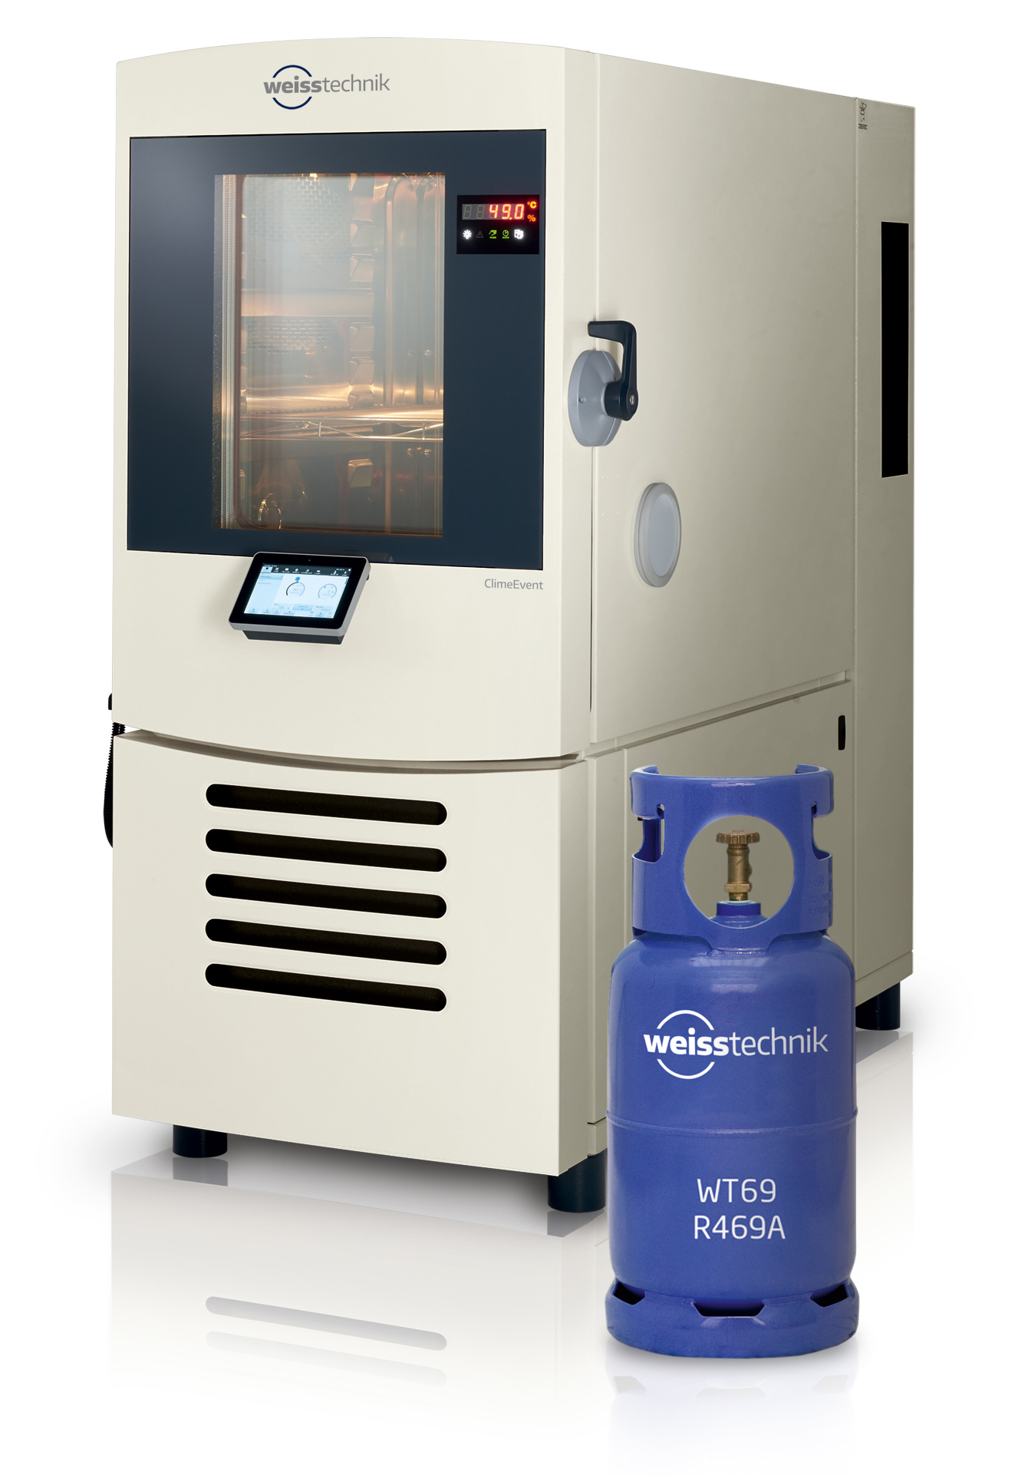
Picture 1: Weiss Technik GmbH, own image
Extensive tests in weisstechnik's climate chambers have proven the compatibility of R469A with Danfoss AVK expansion valves. Unexpected result: R469A was so convincing that Danfossintegratedthe refrigerant for low temperatures into its calculation programme for refrigeration systems.

The Weiss Technik companies
With the slogan “Test it. Heat it. Cool it.”, the Weiss Technik companies offer solutions that can be used across the globe in the fields of research and development, as well in the production and quality assurance processes for numerous products. A strong sales and service organisation with 22 companies in 15 countries at 40 locations offers excellent support to customers and a high level of operating reliability for the systems. The weisstechnik® brand includes customised solutions for environmental simulations, clean rooms, air conditioning, air dehumidifying and containment solutions.
With the test systems from the environmental simulation sector, environmental influences across the globe can be simulated in time lapse. The product to be tested is investigated under real loads in terms of its functionality, quality, reliability, material resistance and lifespan. The dimensions of the test equipment range from laboratory test chambers to test chambers for aeroplane components with a volume of several hundred cubic metres. The Weiss Technik companies are part of the Schunk Group, which is based in Heuchelheim near Gießen/Germany.
Schunk Group
The Schunk Group is a global technology group. The company is a leading provider of products made from high-tech materials – such as carbon, technical ceramics and sintered metal – as well as machines and plants – from environmental simulation to air-conditioning technology and ultrasonic welding to optical machines. The Schunk Group has over 9,100 employees across 29 countries and generated a turnover of 1.35 billion euros in 2019.

