Press Release
Reiskirchen, 26.02.2021

Contact details
yes or no Media GmbH
Claudia Wörner
Vor dem Lauch 4
D - 70567 Stuttgart
Phone +49 711 75 85 89 00
claudia.woerner@yes-or-no.de
www.yesorno.de

Anika Adams
MM Communications
Phone +49 6408 84-6842
anika.adams@weiss-technik.com

Vötsch Industrietechnik GmbH
Produktbereich Wärmetechnik
Greizer Straße 41-49
35447 Reiskirchen
Germany
www.weiss-technik.com

Hygiene concepts for the fishing and food industry
MicroClean AS wins Norwegian Innovation Award together with partner weisstechnik

MicroClean has won NCE Seafood Innovation's "Gründerjule-presangen" aquaculture competition with its commitment to technologies that effectively kill vegetative bacteria, especially listeria. The MicroClean proto-type was industrially tested for eight months at Nordlaks Produkter AS to validate the functionality of the invention.

The Gründerjulepresangen is a competition for aquaculture companies and offers, in addition to a cash prize, entrepreneurial support for young companies. The prize money is primarily used to launch and successfully market the novel product for the aquaculture industry.

New roads for the fisheries and food industry
“In the fishing and food industries, listeria and other disease-causing bacteria such as e-coli and salmonella primarily occur in biofilm on production-related production lines, conveyors, plastic containers, cutting blades or storage bins. This is difficult to control, so many cleaning cycles and often strong chemicals must be used to keep the development under control”, according to Dan Roger Olsen of MicroClean.

Chemical-free cleaning concept
The company's technology is based on the use of wet heat generated by the weisstechnik microwaves and their electromagnetic radiation. According to the company and SINTEF confirmation, this new method effectively kills bacteria by more than 99.99% on all plastic production aids. What's more - even insulation foams that may be affected are disinfected.
The use of chemicals can thus be dispensed with.

1.626 characters (including spaces)

For more information visit www.weiss-technik.com
Reprint free of charge. Please state Weiss Technik companies as a source.

Photo material:

Photo 1: shutterstock_1525582016
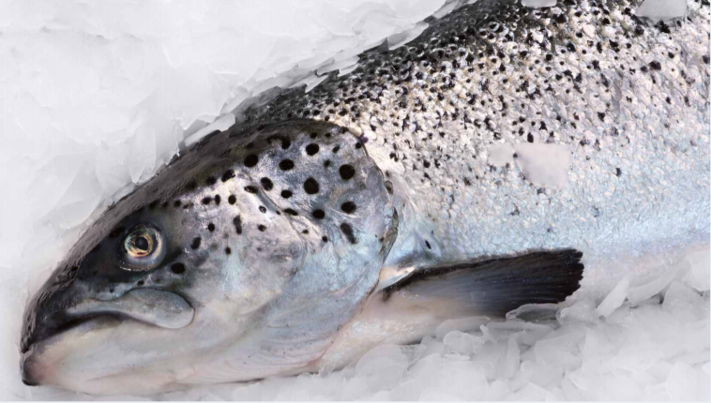
MicroClean AS setzt mit seinem chemikalienfreien Hygienekonzept einenneuen Technologiestandard für die Fischerei- und Lebensmittelindustrie.

Photo 2: Weiss Technik Companies, own image
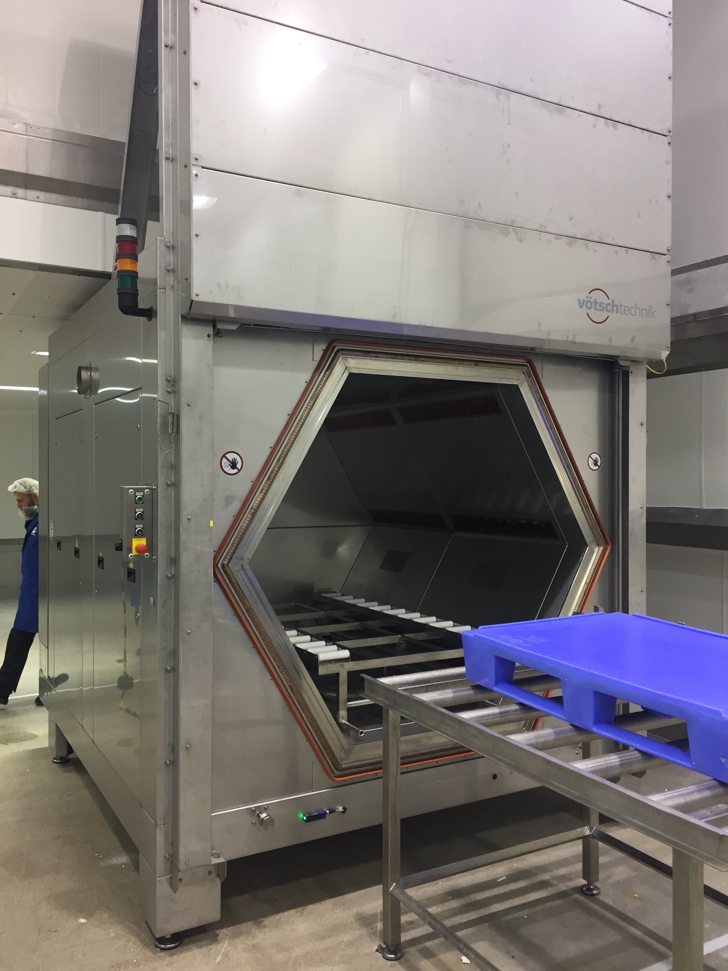
The patented process is suitable for the safe disinfection of all microwave-transparent plastics such as PP, PE or PFTE.
The Weiss Technik Companies
The Weiss Technik Companies offer under the slogan - Test it. Heat it. Cool it. - solutions that are used around the world in research and development as well as in the production and quality assurance of numerous products. A strong distribution and service organisation with 22 companies in 15 countries at 40 locations ensures optimum customer support and guarantees a high degree of operational safety. The brand weisstechnik® includes individual solutions for environmental simulation, heat technology, clean rooms, climatic engineering, air dehumidification as well as containment solutions.
An experienced team of engineers and designers develops, plans and produces high-quality and reliable heating technology systems for virtually any field of application. The wide product portfolio includes heating/drying ovens, clean room drying ovens, hot-air sterilisers, microwave systems and industrial ovens. The portfolio reaches from technologically sophisticated standard versions to customised solutions for individual production operations. The Weiss Technik Companies are part of the Schunk Group based in Heuchelheim near Gießen, Germany.

Schunk Group
The Schunk Group is a globally operating technology company with a global business unit structure. The company is a leading supplier of products made of high-tech materials – such as carbon, technical ceramics and sintered metal – and machines and systems – from environmental simulation and air conditioning to ultrasonic welding and optical machines. The Schunk Group has more than 9.100 employees in 29 countries and achieved sales of €1.35 billion in 2019.

