Press release
Reiskirchen, 28.01.2021

Contact details
yes or no Media GmbH
Claudia Wörner
Vor dem Lauch 4
D-70567 Stuttgart
Phone +49 711 75 85 89 00
claudia.woerner@yes-or-no.de
www.yesorno.de

Anika Adams
MM Communications
Tel +49 6408 84-6842
anika.adams@weiss-technik.com

Weiss Umwelttechnik GmbH
Greizer Straße 41-49
35447 Reiskirchen
Germany
www.weiss-technik.com

Damper Shock
weisstechnik with new temperature shock test chamber

With the Damper Shock, weisstechnik is expanding its portfolio of temperature shock test chambers. The new test chamber from the ShockEvent series is predestined for test specimens, which are sensitive to vibrations or energised.

The special feature of the Damper Shock is the stationary test space. Temperature-controlled hot and cold air is generated in chambers above and below the test space. Via Dampers, the air can be led to the test specimens. This is the major difference from horizontal and vertical shock test chambers, where the test specimens are located in a test cage that can be moved between two temperature chambers.

Meeting low-vibration requirements
The Damper Shock from weisstechnik, with its static test chamber, is ideal for vibration-sensitive measuring technology and sensors, as well as for energised test specimens that are to be subjected to shock treatment without any further influences. It fulfils the requirements for standardised temperature stress tests, such as the Japanese standard JASO D-014-4 and EIAJ ED-2513B Na and various grades of MIL-STD-883H and 202G.

Simple cable guiding
In addition, the new test chamber has been designed as a 2- and 3-zone shock tester, which now allows ambient air flow in. This provides more flexibility for a variety of test requirements. Another advantage of the stationary test chamber is the simple cable guiding for measuring equipment. The cables are stationary in the test space and do not move, unlike in other shock test models.

For large laboratories and quality assurance
With outer dimensions of 1970x1595x1765 mm, the test chamber is used by development laboratories and quality assurance in production halls. The test space volume is 210 litres with dimensions of 700x500x600 mm and allows a maximum test specimens load of 100 kg. The Damper Shock can easily be connected to other test chambers and be operated with the familiar S!MPATI control software.

Sales ex stock
weisstechnik supplies its Damper Shock either with refrigerant R-23 or the new R-469A, winner of the German Innovation Prize. In the test space, the temperature range is between -65 and +200 °C. The test chamber will be sold ex stock, which ensures short delivery times.

2,279 characters (including spaces)

For more information visit www.weiss-technik.com
Reprint free of charge. Please state Weiss Technik companies as a source.

Photo material:

Picture 1: Weiss Umwelttechnik, own image

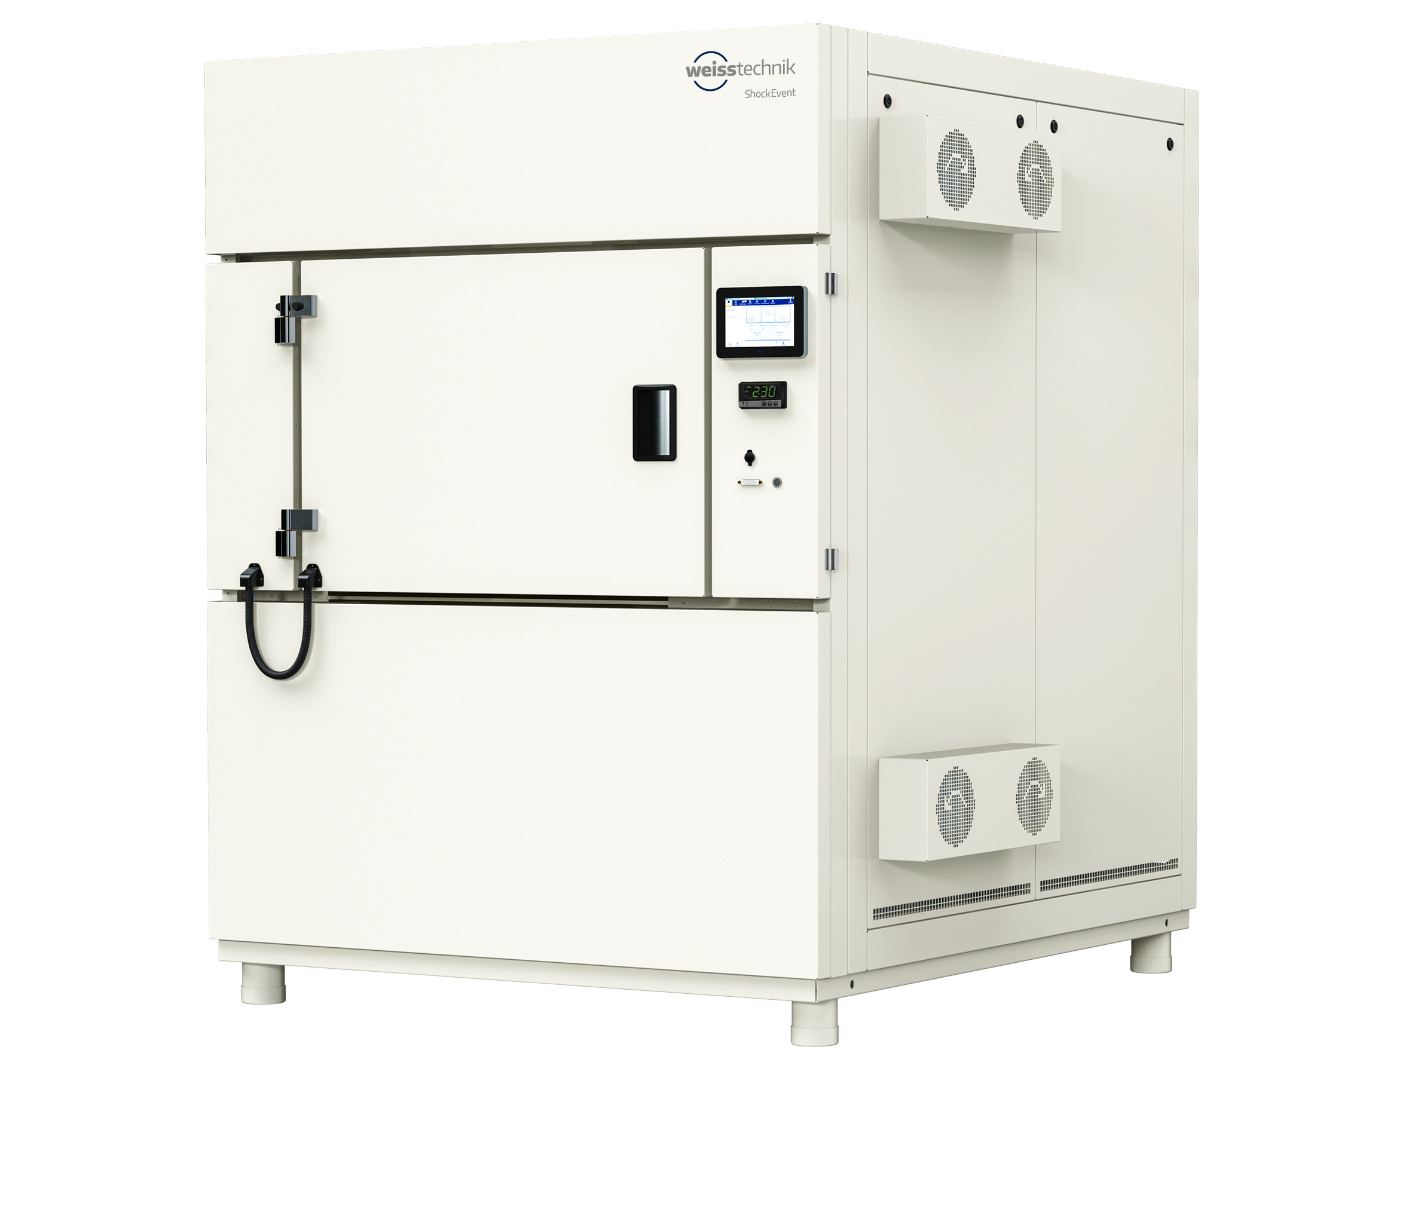
With the Damper Shock, weisstechnik is expanding its portfolio of temperature shock test chambers. The Damper Shock is particularly suitable for testing vibration-sensitive measuring instruments and sensors.

The Weiss Technik companies
With the slogan “Test it. Heat it. Cool it.”, the Weiss Technik companies offer solutions that can be used across the globe in the fields of research and development, as well in the production and quality assurance processes for numerous products. A strong sales and service organisation with 22 companies in 15 countries at 40 locations offers excellent support to customers and a high level of operating reliability for the systems. The weisstechnik® brand includes customised solutions for environmental simulations, clean rooms, air conditioning, air dehumidifying and containment solutions. With the test systems from the environmental simulation sector, environmental influences across the globe can be simulated in time lapse. The product to be tested is investigated under real loads in terms of its functionality, quality, reliability, material resistance and lifespan. The dimensions of the test equipment range from laboratory test chambers to test chambers for aeroplane components with a volume of several hundred cubic metres. The Weiss Technik companies are part of the Schunk Group, which is based in Heuchelheim near Gießen/Germany.
The company is a leading provider of products made from high-tech materials – such as carbon, technical ceramics and sintered metal – as well as machines and plants – from environmental simulation to air-conditioning technology and ultrasonic welding to optical machines. The Schunk Group has over 9,100 employees across 29 countries and generated a turnover of 1.35 billion euros in 2019.

