Professional Article
Reiskirchen, 18.02.2021

Editorial
txtconcept
Tel +49 641 58174-27
m.michels@txtconcept.de

Contakt
yes or no Media GmbH
Claudia Wörner
Vor dem Lauch 4
D - 70567 Stuttgart
Phone +49 711 75 85 89 00
claudia.woerner@yes-or-no.de
www.yesorno.de
Anika Adams
Marketing Manager
Phone +49 6408 84-6842
anika.adams@weiss-technik.com

Weiss Umwelttechnik GmbH
Greizer Straße 41-49
35447 Reiskirchen
Deutschland
www.weiss-technik.com
Testing & Knowledge instead of Trial & Error
Test technology as a central enabler of
E-mobility and autonomous driving

The automotive industry remains in a state of continuous evolution, battery-powered and semi-autonomous vehicles are on the rise. This increases the responsibility of vehicle manufacturers and suppliers. New test technology, new test procedures and new test standards are required to ensure that Li-ion batteries will provide even more power, have a longer service life and allow for longer ranges in the future. weisstechnik makes an important contribution to this. As the global market leader for environmental simulation and a long-standing partner of the automotive industry, weisstechnik enables and secures tomorrow's mobility.

The enthusiasm for automotive solutions is a tradition at weisstechnik. For more than 65 years, the German company has been developing sophisticated test technology for OEMs, component suppliers and test institutes. "The automotive sector is of great importance to us. On the one hand, because its dynamics challenge our developers anew day after day. On the other hand, because it is a gigantic national and international market which we serve well and gladly," explains Peter Kuisle, Managing Director Sales and Service of the Environmental Simulation business unit.

weisstechnik's product range is extremely versatile and ranges from compact temperature test cabinets to large-volume climatic test chambers and test benches for complete vehicles. With this versatility, the company also scored points with the FEV Group. The internationally successful development service provider commissioned weisstechnik to equip the currently largest battery test centre worldwide. For this purpose weisstechnik planned and built more than 60 test facilities within only 18 months. These were successively put into operation so that they could already be used during the construction phase of the test centre.

In addition to numerous temperature and climate test cabinets and chambers, these include salt spray systems, dust and vacuum test chambers and a 350 kN vibration test chamber. The test systems were connected to a central refrigeration unit and integrated into FEV's control system.

weisstechnik has accompanied the testing of Li-ion batteries for about 15 years with environmental simulation systems for cells, modules, battery packs, complete drive units and battery management systems (BMS). It is important to get the enormous energy density of Li-ion batteries and the associated danger of a thermal runaway technically under control. In order to protect the test material, the test facility and above all the test personnel in the best possible way, weisstechnik has therefore developed a hazard-level modular system which defines suitable measures for each danger level and specifies ATEX-compliant explosion protection measures.

Testing of batteries for electric vehicles requires knowledge of all relevant standards and how they can be safely implemented in test solutions. In addition to the higher-level automotive standard LV124, UN38.3 and OEM-specific standards play an important role here. weisstechnik offers suitable standard products for many testing requirements. In addition, the company realises customised planned and executed special solutions, for example with shaft feedthroughs, energised test specimens, racks for efficient test specimen handling or safety devices.

Especially in the field of special constructions weisstechnik enjoys an excellent reputation in the industry. Recently, the company was also able to support the development of standards at an EU research centre in Petten, Netherlands. Here, an explosion-proof test stand for ATEX Zone 1 was developed for the world's first testing facility for energised Li-Ion battery tests with CT images, which is secured up to Hazard Level 6. Here, energised battery modules are tested under various climatic conditions. A computer tomograph illuminates the test specimens mounted on a rotary table from all directions. The complete 3D data of the battery generated in this way allows conclusions to be drawn about its condition during the test.

Test systems from weisstechnik are used in research and development to accelerate processes and simulate environmental influences. Furthermore, they are used in quality testing and quality assurance when serial defects or safety risks need to be detected. There are almost no limits to the testing possibilities, explains Hartmut Möglich, Global Sales Director: "With our testing facilities for Li-ion batteries, we are able to reproduce all the climatic conditions of the world in a test laboratory and to stress the test items in accordance with the standards. We simulate a cold start at the North Pole, a bumpy ride through the dusty desert or the city traffic of Bangkok and realise, among other things, extreme temperature changes, strong light irradiation, vibrations, dust and splash water".

High-precision testing equipment is a prerequisite for standard-compliant and comparable tests. Because only if the required climatic parameters can be reliably reproduced at any time can the test results be meaningful and resilient. To ensure this, weisstechik has two of its own DaKKs calibration laboratories. These calibrate test systems, test and measuring equipment in the laboratory or at the customer's site, depending on the requirements.

Parallel to the growing demand for electric vehicles, the market for partially and fully automated vehicles is also developing very positively. These require numerous sensors, control units and other sensitive electronic components. A malfunction or failure can easily lead to an accident. It is therefore important that these components function safely at all times and under all conditions. In order to check this for every single component, weisstechnik offers special end-of-line test tunnels for the energised testing of electronic components.

The change in the automotive industry also leads to new inspection tasks and requirements. In many cases, the industry needs new testing facilities for this. In order that these do not fail in an economically tense situation due to short-term financial bottlenecks, weisstechnik offers flexible solutions for payment and financing: classic purchase and leasing options as well as pay-per-use solutions. This enables companies to use the latest plant technology without affecting the cash flow.

A decisive factor for the technical and economic success of a test facility is its high operational reliability. Therefore, after-sales service also plays an important role. An efficient, area-wide service network with top-trained service technicians, high first-fix rates and a worldwide secured spare parts logistics contributes significantly to the return-on-investment of weisstechnik test systems.

6.752 characters (including spaces)

For more information visit www.weiss-technik.com
Reprint free of charge. Please state Weiss Technik companies as a source.

Photo material:
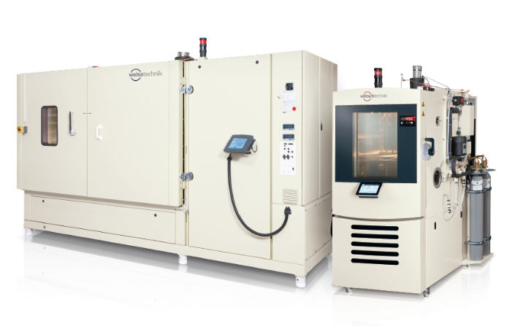
Picture 1: Weiss Umwelttechnik
weisstechnik has accompanied the testing of Li-ion batteries for about 15 years with environmental simulation systems for cells, modules, battery packs, complete drive units and battery manage-ment systems (BMS).

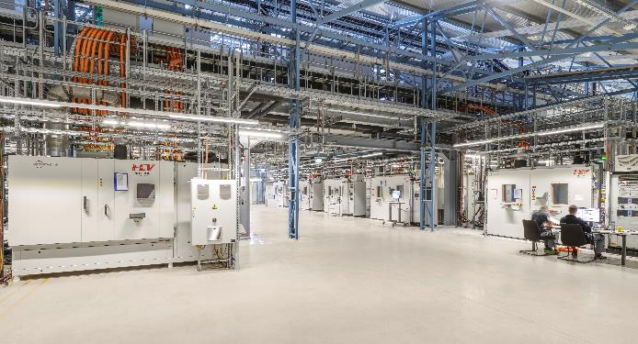
Picture 2: FEV Group
The internationally successful development service provider FEV Group com-missioned weisstechnik to equip the currently largest battery test centre worldwide.

The Weiss Technik companies
With the slogan “Test it. Heat it. Cool it.”, the Weiss Technik companies offer solutions that can be used across the globe in the fields of research and development, as well in the production and quality assurance processes for numerous products. A strong sales and service organisation with 22 companies in 15 countries at 40 locations offers excellent support to customers and a high level of operating reliability for the systems. The weisstechnik® brand includes customised solutions for environmental simulations, clean rooms, air conditioning, air dehumidifying and containment solutions. With the test systems from the environmental simulation sector, environmental influences across the globe can be simulated in time lapse. The product to be tested is investigated under real loads in terms of its functionality, quality, reliability, material resistance and lifespan. The dimensions of the test equipment range from laboratory test chambers to test chambers for aeroplane components with a volume of several hundred cubic metres. The Weiss Technik companies are part of the Schunk Group, which is based in Heuchelheim near Gießen/Germany.

Schunk Group
The Schunk Group is a global technology group. The company is a leading provider of products made from high-tech materials – such as carbon, technical ceramics and sintered metal – as well as machines and plants – from environmental simulation to air-conditioning technology and ultrasonic welding to optical machines. The Schunk Group has over 9,100 employees across 29 countries and generated a turnover of 1.35 billion euros in 2019.

