Press release
Reiskirchen, 11.05.2022

Editor
yes or no Media GmbH
Claudia Wörner
Vor dem Lauch 4
D - 70567 Stuttgart
Tel +49 711 75 85 89 00
claudia.woerner@yes-or-no.de
www.yesorno.de

Contact details
Bianca Dort
Marketing Manager
Tel +49 6408 84-6842
bianca.dort@weiss-technik.com

Weiss Technik GmbH
Greizer Straße 41-49
35447 Reiskirchen
Deutschland
www.weiss-technik.com

The highest standard for climatic testing
The new ClimeEvent

Six years ago, weisstechnik changed the market of climatic test chambers with the ClimeEvent series. The second generation of machines is now continuing this success story. The climatic test chambers of the new ClimeEvent series have been designed to meet customer requirements and have been completely revised technically, visually and functionally as a result of the practical experience which has been acquired. The result: the best climatic test chambers from weisstechnik.

Focus on the essentials
Since the first ClimeEvent units came on the market, the world of climatic testing has changed significantly: Increasingly demanding end customers have led to ever more complex testing requirements. With new refrigerants, new control software and optional storage, weisstechnik has responded to these increasing requirements by continuously developing new solutions. Now the company is presenting the second, completely revised generation of machines. "Nowadays, it is no longer enough to offer a robust and reliable test chamber, that is something that is expected. Our customers need comprehensive testing solutions that simplify their day-to-day testing and actively support them. Such as our new ClimeEvent test chambers," explains Ralph Theiss, Standard Product Manager at weisstechnik.

From practical testing to development
The success story of the ClimeEvent series includes tens of thousands of test chambers that are used in development departments, test laboratories and quality assurance departments worldwide. With so many test chambers in use, we have also received a wide range of feedback from day-to-day testing. "We have continuously evaluated this feedback and used it as a starting point for the ongoing development of the ClimeEvent family. It was important for us to answer everyday, practical use cases with a user-oriented, technical solution and to provide users with something of real added value," continues Theiss.

Design follows everyday testing
The result is a striking new design: straight-lined and discreet, the test chambers fit perfectly into any test laboratory, both technically and visually. The control panel, which has been enlarged from 7" to 10", is equipped with a faster processor, improves the user's overview and increases ease of use. The retractable design integrated into the front of the unit means that it is better protected against external mechanical influences. The design of the top edge emphasises the elegant lines and conceals all of the test chamber's fittings. There is extra storage space on the side of the unit for test equipment such as data loggers, laptops, grid shelves, cables or access port plugs. This ensures a tidy testing environment and increased occupational safety. The front screen, which can be darkened at the push of a button using electrochromic technology, is a technological innovation. This means the test specimen can be protected from unwelcome eyes - ideal for laboratories that have to comply with confidentiality agreements.

Impressive inner qualities
The new ClimeEvent test chambers have also been fundamentally revised in terms of their testing technology. This includes optimised water management with a 27-litre storage tank that displays the remaining amount of deionised water on the control panel and also indicates the expected running time. The water bath has also been enlarged, which increases the humidification capacity to such an extent that demanding climatic tests such as the K15 of the LV124 (BMW condensation test) are now also possible without additional humidification. The new patented absolute humidity control enables even more control accuracy, even at high dew points. This new type of control reduces thermodynamically induced deviations during climate changes and the transient amplitudes of the humidity values, while also achieving faster rates of humidity change. The result is reproducible test conditions with a new level of precision.

Simply better testing
To make the preparation and execution of tests more comfortable and safer, the contoured sides of the test spaces have been replaced by a rail system with a perforated pattern. These increase flexibility, simplify handling and enable the combination of conventional grid shelves with pull-out rails. In addition, screws with internal threads are integrated in the rail system, which ensure simplified assembly of test set-ups and enable a variety of special configurations. The LED lighting mounted on the test space ceiling ensures optimum lighting conditions, even when the door is open. This also minimises the amount of heat entering the test space compared to the previously used halogen lighting. The LED status bar integrated in the test space door also offers more convenience and safety. The operating conditions of the test chambers can also be clearly seen from a distance, which further simplifies the management of several test chambers in one laboratory.

Shaping the future together
All in all, the new ClimeEvent test chambers offer testing technology that is as innovative as it is sophisticated and continues the development of the successful ClimeEvent family in the interests of the customer. The new test chambers with test chamber volumes of 180 - 600 litres will be available with temperature change rates of 3 and 5 K/min from mid-May this year. Larger versions and those with higher temperature change rates will follow successively. Peter Kuisle, Managing Director Sales and Service at Weiss Technik is looking forward to a successful product launch. "The new ClimeEvent family offers the perfect foundation for the developments of tomorrow. In doing so, we intend to make our contribution towards shaping the future alongside our customers. They are the best test chambers we have ever had."

(5,794 characters with spaces)
Reprint free of charge. Please state Weiss Technik GmbH as a source.

Photo material:

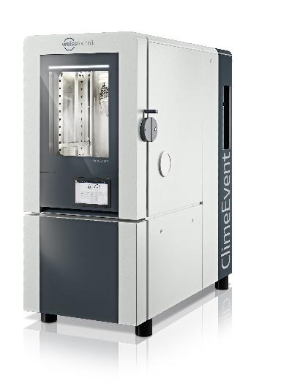
Picture 1: Elegant, functional and suitable for every testing laboratory: the newly designed ClimeEvent

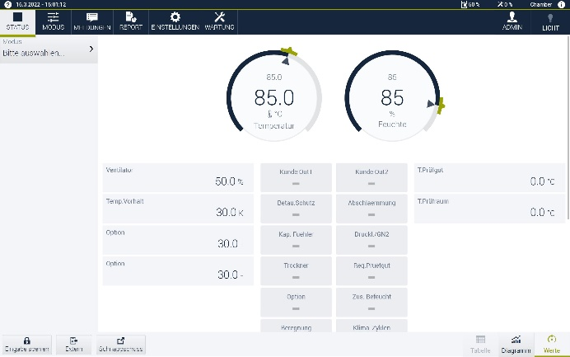

Picture 2: The patented absolute humidity control enables even more precise climatic tests.

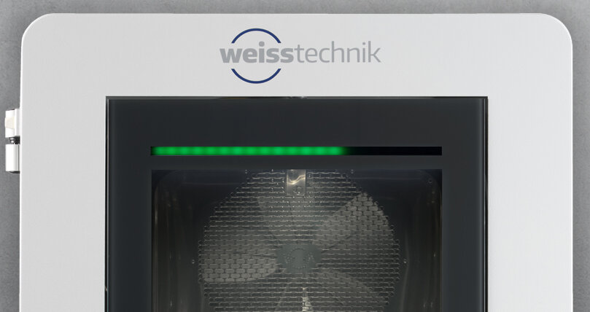
Picture 3: Keep an eye on everything: The LED status bar provides continuous information on the current operating status.

The Weiss Technik companies
The Weiss Technik companies include the product areas of environmental simulation, heating technology, air conditioning technology and pharmaceutical technology (www.weiss-technik.com). Customers receive solutions and products that are used in research and development as well as in production and quality assurance. A strong sales and service organisation with 22 companies in 15 countries at 40 locations supports the customers and ensures the operation of the systems - around the globe. The Weiss Technik companies are part of the Schunk Group based in Heuchelheim near Gießen.
Schunk Group
The Schunk Group is a global technology company. The company is a leading supplier of products made of high-tech materials – such as carbon, technical ceramics and sintered metal – as well as machines and systems – from environmental simulation and air conditioning to ultrasonic welding and optical machines. The Schunk Group has around 9,000 employees in 29 countries and achieved sales of €1.2 billion in 2020.

